 | Tech It Easy | Access Technologies, Inc.  September 2021 Edition  Editor: Laurie Brooks

Inside this Issue:
Fidgets for the Future | 1-2, 10-11
ATM - MarketPlace | 3 – 8
Bargain Basement | 9
iCanConnect-Oregon | 12

Fidgets for the Future

Fidget toys were one of the top 10 trending toys in 2017. “Fidgets” (toys and devices to make fidgeting more effective and entertaining) have practical uses for adults and children.
Studies have shown that fidgeting with an object helps individuals stay focused when doing a long task or sitting still and attentive for long periods of time. They have been proven to assist with conditions like ADD, ADHD, autism and anxiety.
Improve attention with a fidget

An effective fidget doesn’t distract you from your primary task because it is something you shouldn’t have to think about. If you have ever clicked a pen repeatedly, tapped it on a desk, or played with a ring you were wearing, you have used a fidget device. Other examples of fidgeting include tapping your foot, bouncing your knee or touching each finger to your thumb repeatedly – you might benefit from a fidget!
What to look for when considering a fidget?
- Quality – it will get frequent, repetitive use.
- Texture and Feel – light-weight, moving parts, should be soothing.
- Entertaining - but not distracting (annoying sounds/colors), should be an outlet for excess energy.
Many times, fidget toys go hand-in-hand with sensory toys. There are a number of fidgets commercially available that target all age groups. Inclusive kits are available online containing many of the ones featured below.
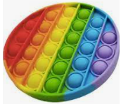
Pop Its are the newest fidget toy available. It consists of a silicone sheet of dimples that the user pushes back and forth, similar to bubble wrap. Pop Its can be used by either popping the bubbles back and forth or pressing all of the bubbles down and then flipping it over to start again. They come in several shapes, sizes, and colors and even as keychains.
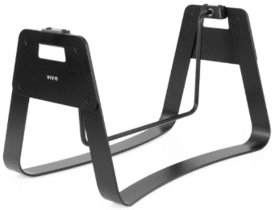
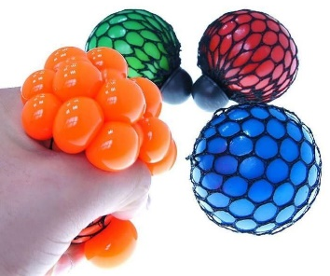
Mesh Squishy Balls are sometimes marketed as a modern stress ball, which is basically what a fidget is. The user squeezes the liquid-filled gel ball to watch bubbles pop out of the mesh net. Squishy balls are not the only balls for fidgeting. Many other balls are made of foam or are spikey or even bouncy.
Check with your teacher before taking a fidget into your classrooms.

Fidget bars come in many styles and for many uses. They can be attached to a student’s desk in the classroom as a bar on a stretchy cord, or a standalone swing bar. They can be used seated or standing and provide an outlet for restless legs.
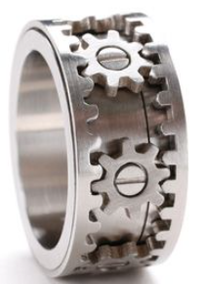
Fidget spinners are even being incorporated into everyday items like wedding rings and watches. Fidget rings have a center band that rotates or spins around the stationary band. Another form is multiple interlocking bands, or rings that come apart like puzzle pieces, or rings with moveable pieces such as beads or adornments.
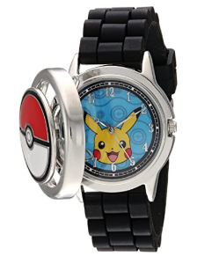
The Pokémon Spinning Analog Watch which has a fidget spinner attached to the top of a metal cover with a spring hinge to keep it closed when spinning. Opening the lid reveals the watch face. Other versions feature an outer bezel that rotates around an open watch face.

(Continued on page 10 –Fidgets)

Assistive Technology MarketPlace | Page 3

Oregon’s  Statewide Assistive Technology Program | September 2021 | 2225 Lancaster Dr. NE  Salem, OR 97305  www.accesstechnologiesinc.org  info@accesstechnologiesinc.org

NOTE: Our distributors are experiencing rising costs of raw materials. Aluminum alone has increased 25% since January! ATI is continuing to work diligently with our distributors to minimize costs and provide you with the lowest prices possible.

Canes / Crutches
Cane – Adjustable  Adjustable Designer Canes available with Derby handle, T-handle, Offset handle, Pistol Grip Gel, Pistol Grip Wood. Folding & Non-Folding. $19 | Cane – Crookneck  Standard aluminum cane with round vinyl hand grip. Locking ring ensures added safety after adjustment. Weight capacity 300 lbs. $19 | Cane – EZ Rise  Combines rising assistance with a walking cane. Second soft grip handle is positioned approx. 8-inches below offset grip handle. $33
Cane – Quad Base  Quad base cane with offset padded hand-grip. Large or small base style.  Small Base: $20  Large Base: $22 | Cane – Tall and Large  Cane has 1-inch steel tubing, offset handle with vinyl grip and wrist strap. Weight capacity 500 lbs. $22 | Crutches – Forearm or Underarm  Leg & forearm adjust independently, ergonomic contoured arm cuffs, vinyl hand grips, extra-large tips for added stability.  Adult Forearm: $45  Tall Forearm: $50  Underarm Style: $35

Hospital Beds
Bed Assist Rail  Easy, quick, no tool assembly. Comes in two pieces. Safety strap wraps around mattress or box spring to ensure a secure fit. Fits single, twin, double, queen or king size bed. Handle with multiple crossbars creates easy grip for multiple height use. Rail Dimensions: 11.5-inches (W) x 20.75-inches (H) x 21.5-inches (D). Weight Capacity 250 lbs. $59 | Table – Pivot Tilt C Base  The mast of the table pivots and can be locked in one of three positions from flat on the floor to 90 degrees. Pivot feature allows tabletop to be positioned closer to individuals in a bed, sitting in a wheelchair, or folded for storage. Four 2-inch casters (two locking) Tabletop adjustment 28-37 inches. Tabletop Surface Dimensions: 25-inches (W) x 28-inches (D). $85 | 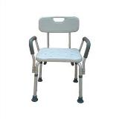  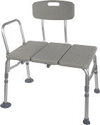  Bath Chair w/ Back and Arms  Bath Transfer Bench

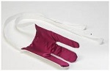
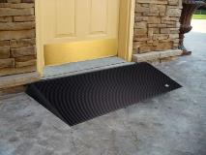
Terry Sock Aid
Walker Glides
Rubber Threshold Ramp

Lifts and Transfer
Transfer Board  Bridge gap between two transfer points making patient transfers easy and safe. 29.5-in. x 7.5-in., solid pine with two hand slots to assist the caregiver in placement and removal of the board. Weight limit 440 lb. $45 | Car Caddie  Provides a little extra standing assistance when exiting a vehicle. No-slip handle, easy installation, adaptable to fit most framed windows, adjustable in height. $17 | Gait Belt – Quick Release  Sturdy buckle makes it easier to put on and take off the belt. Size the belt and never have to re-thread! Buckle snaps closed, opens with a squeeze. Choice of 54 or 72 inch. $25
Leg Lift  A simple way to help lift your leg. 36-inches long with hand and foot loops. $12 | 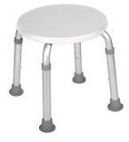  Round Bath Stool | 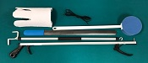  Six Piece Rehab Kit

Personal Care / Dressing
4 Piece Rehab Kit  Kit includes 1 of each:  Light weight reacher, long-handled bath sponge, choice of terry cloth or semi-rigid sock-aid, and plastic heavy-duty shoehorn.  Kit w/ Semi rigid sock aid $20  Kit w/ Terry sock aid $22 | 5 Piece Rehab Kit  Kit includes 1 of each:  Light weight reacher, long-handled bath sponge, choice of terry cloth or semi-rigid sock-aid, dressing stick, and plastic heavy-duty shoehorn.  Kit w/ Semi rigid sock aid $25  Kit w/ Terry sock aid $27 | 6 Piece Rehab Kit  Kit includes 1 of each:  Light weight reacher, long-handled bath sponge, choice of terry cloth or semi-rigid sock-aid, leg lifter, plastic heavy-duty shoehorn, and a pair of elastic shoelaces.  Kit w/ Semi rigid sock aid $32  Kit w/ Terry sock aid $34
Cold Pak – Gel Reusable  Apply cold therapy to localized areas. Remains cold for approximately 30 min. Easily conforms to body contour. Reusable, heavy-duty design. Size: 11x14. $15 | Grabber / Reacher  Lightweight, locking plastic grabber claw with magnetic tip or non-slip rubber grabber suction cups.  Claw style $10  Suction style $17 | Elastic Shoelace  Tie shoes once and never tie again. Reduces pressure points in shoes. Black, Brown, Tan, or White. $3 per pair.
Dressing Stick  A simple way to help those needing assistance dressing. 27-inch wooden handle with “S” hook on one end and “?” shaped hook on the other end. $5 | Easy Opener  Provides support with minimum strength to easily open bottles, bottle caps, pull tabs and box tops. $5 | Long Handled Bath Sponge  The bath sponge has a long handle to assist with washing the hard-to-reach areas. $5
Long Reach Comfort Wipe  Toilet tissue holder reaches where you can’t. Curved design to put pressure where you need it. Flexible head with secure grip and easy release button. No touching, No mess. $10 | Shoehorn Metal or Plastic  Sturdy latex-free metal with rubber handle or sturdy plastic for those needing assistance putting on shoes or who have arthritis or trouble grasping.  Metal style $12  Plastic style $5 | Sock aid Semi Rigid or Terry  A simple way to help put socks on when bending is a pain. Semi-rigid plastic, cord with foam handles, or terry cloth with loop handles.  Semi Rigid style $10  Terry Cloth style $12

Ramps
Threshold Ramp - Aluminum  Lite weight, free standing ramp, full-width design 34 inches wide seam-free surface. For doorways, raised landings, single steps, and sliding glass. Weight capacity 600 lbs.  1-inch (H) $50  2-inch (H) $60 | Threshold Ramp Rubber.  Slip-resistant, from recycled tires. Weight capacity 850 lbs.  1.5-inch (H) x 36-in. (W) $90  2.5-inch (H) x 48-in. (W) $120 | 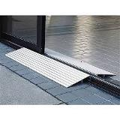  Threshold Ramp
Advantage Trifold Ramps.  Access vans, steps, and raised landings. Skid resistant surface, 29.5-inches wide, supports up to 800 lbs.  6-foot length: $291  8-foot length $415  10-foot length $574 | 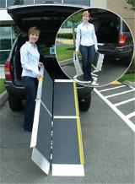  Advantage Trifold Ramp | Top Lip Extensions  Extends the Advantage Trifold, Suitcase Advantage, and Signature ramps. These optional plates increase the standard 3-inch ramp lip to 9, allowing the ramp to clear the rear bumper of SUVs and vans. Attaches to the top lip. $40 (per pair)

Shower / Bath
Bath Chair  without Back or Arms  Lightweight, durable, and corrosion proof. Legs are height adjustable in 1-inch increments, and angled with suction style tips; providing additional stability. Seat Height 15.5 - 19.5 inches. Seat Dimensions: 19.25-inches (W) x 11.5-inches (D). Weight capacity 400 lbs. $30 | Bath Chair with Back  with or without Arms  Aluminum frame is lightweight, durable and corrosion proof. Legs are height adjustable in 1-inch increments and angled with suction-style tips to provide additional stability.  Seat dimensions: 19.25-in (W) x 11.5-in. (D). Weight Limit 400 lbs. With Padded Arms $59  Without Arms $35 | Bath Chair Heavy Duty  with or without Back  Frame has width/depth cross braces attached, Blow molded bench. Euro-style clip for leg height adjustment. Height adjusts in 1-inch increments. Seat Height 14 - 19 inches. Weight Limit 500 lbs.  Without back $60  With back $80
Bath Mat  Adds safety by providing a large slip proof surface. Held securely by multiple suction cups. Mold resistant, latex free rubber. Size 15.75-in. x 35.5-in.  $20 | Bath/Shower Transfer Bench  A-frame construction provides stability. Durable blow-molded plastic bench and backrest. Height adjusts in ½ inch increments with unique (Dual Column) extension legs. Weight Limit 400 lbs. $60 | 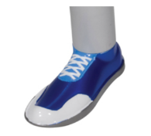  Walker Glides
Bath Chair Round  Compact round shower stool for tight spaces. $35 | 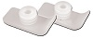  Walker Glide Skis

Shower / Bath
Commode Standard 3-in-1  Gray powder-coated, steel-welded construction. Durable plastic snap-on seat with lid, removable tool-free back. Plastic arms for comfort, 12-quart bucket with metal handle, cover and splash shield. Width between arms is 18 inches. Weight capacity 350 lbs. $50 | Commode Standard 3-in-1 with Drop Down Arms  Drop down arms allow for easy transfer. Includes 12-quart pail, sleeve & lid and adjustable legs. Weight capacity 300 lbs. $119 | Commode Heavy Duty 3 in 1 Folding  Gray powder-coated, steel-welded construction, Durable plastic 16 ½ inches deep. snap-on seat with lid, removable tool-free back, plastic arms for comfort, 12-quart bucket with metal handle, cover and splash shield. Width between arms is 24 inches. Seat width: 13.5 inches, Seat depth: 16.5 inches. Weight capacity 650 lbs. $159
Rolling Shower Chair / Commode  Lightweight and durable, padded, open front, vinyl toilet seat, 4 non-skid, rust resistant, swivel casters (2 rear locking). 12-quart. bucket and cover. Weight capacity 300 lbs. $179 | Toilet Safety Rails  Make the bathroom safer for individuals needing assistance in raising from a seated position. Adjustable arm width and height 25.5 - 29.5 inches, attaches to standard toilet. Weight capacity 300 lbs. $40 | Raised Toilet Seat  Hinged  Two-piece, hinged seat riser. Allows the ring to be lifted for cleaning. Elevates by 3.5 or 4 inches. Hardware kit included.  Standard or Elongated Styles.  3.5-inch rise: $50  4-inch rise: $55
Raised Toilet Seat Locking with Removable Arms  Round or Elongated style available. Heavy-duty molded plastic construction provides additional strength and durability. Locking device has larger, heavy-duty worm screw and locking plate to ensure a safe, secure fit. Raises toilet seat height 5 inches. $68 | 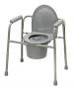  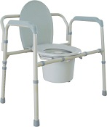  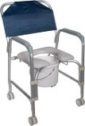  Commodes | 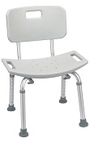  Bath Chair with Back

Walker / Accessories
Cup Holder – Universal  Universal Cup Holder easily attaches to most wheeled walkers, wheelchairs and rollators. $19 (pair) | Glide Caps  Allows walker to slide smoothly over most surfaces. These replace existing rubber tips for smoother and easier gliding, Ideal for indoor use. $9 (pair) | Glide Covers  The glide cover can easily be added to the walker, for use over existing rubber tip. The glide covers increase the life of the walker tips. $9 (pair)
Glide Skis  The glide skis can easily be added to the walker back legs to help “glide” the walker.  $10 (pair) | Glides – Bunny Slippers  Stylish Slippers allow walker to glide easily & smoothly over most surfaces. (Colors: Blue, Pink, or Purple) $10 (pair) | Glides – Sandals  Stylish Sandals allow walker to glide easily & smoothly over most surfaces. (Colors: Blue, Pink, or Purple) $10 (pair)

Walker / Accessories

Glides – Sneakers  Stylish tennis shoes allow walker to glide easily & smoothly over most surfaces. (Blue, Pink, or Purple) $10 (pair) | Glides – Tennis Ball  Provides a quiet, smooth and durable glide when used with walker. $18 (pair) | Walker Basket  Used with most 1 inch folding walkers. Includes plastic insert tray and a cup holder; makes transporting personal items a cinch. $24
Walker Tray Universal  Fits most manufactured walkers. Easy to clean, durable plastic with a cup holder. $39 | Walker Rear Glide Brakes  For use on back of wheeled walkers. Nylon tip glides along surface until weight is applied to hand grip, which activates the rubber tip brakes. Allows for 8 height adjustments. Comes with or without 3inch wheels.  $25 (pair) | Walker Tall Extension Legs  Makes height adjustments from 36 to 43 inches on a standard adult walker. $25 (pair)
Walker Wheels 3-inch Swivel  These heavy-duty swivel wheels allow walker to roll easily and smoothly in any direction and over irregular surfaces; includes rear glide caps. 8 height adjustment settings. $19 (pair) | Walker Wheels 5-inch  Non-Swivel  These heavy-duty non-swivel wheels allow walker to roll easily and smoothly in any direction and over irregular surfaces; includes rear glide caps, 8 height adjustment settings. $18 (pair) | Walker Wheels 5-inch Swivel  Rubber wheels with rear glide caps allow walker to roll easily and smoothly. Converts folding walker into wheeled walker, 8 height adjustments. 2-sided positioning. $25 (pair)
Walker Adult Double Button With or Without Wheels  Deluxe folding walker, double button folding action. Vinyl hand grips.  Walker without wheels: $69  Walker with 5-inch wheels: $69 | Walker Adult Double Trigger With or Without Wheels  Pull up on extended dual palm trigger release levers, ideal for individuals with limited finger dexterity. Vinyl, ribbed contour handle grips, Weight capacity 350 lb.  Walker without wheels: $59  Walker with 5-inch wheels: $59 | Walker Adult Heavy Duty Double Button With or Without Wheels  Folding, double button action. This walker is designed with a wider and deeper frame design for larger individuals up to 500 lbs.  Walker without wheels: $95  Walker with 5-inch wheels: $109
Walker Junior Double Button With or Without Wheels  Deluxe folding walker, double button folding action. Vinyl hand grips. Weight capacity 350 lb.  Walker without wheels: $69  Walker with 5-inch wheels: $69 | Walker Junior Double Trigger With or Without Wheels  Pull up on extended dual palm trigger release levers, ideal for individuals with limited finger dexterity. Vinyl, ribbed contour handle grips, 350 lb. weight. capacity.  Walker without wheels: $59  Walker with 5-inch wheels: $59 | 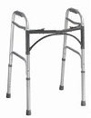  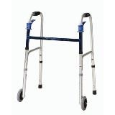  Double Button Walker  Double Trigger Walker

Walker / Accessories
Walker – Hemi  Only 3 inches deep when folded with two-levels. Provides support for standing from a seated position. For one arm use, lightweight side walker combines support and stability. Extra hand grip for ease of folding. $45 | Walker Clever Lite  The Clever-Lite Walker sets itself apart from other wheeled walkers in that it features a seat with a flexible backrest that can flip up or down, so you to rest when needed. Also, this walker has wheels that can be either set to swivel or fixed positions, giving you more control of how you want to roll. $126 | Rollator 2 in 1 – Duet  Combines transport chair & rollator into one. Contoured, two position, padded back rest attaches to front or back, large 8-inch casters. Lock prevents accidental folding. Footrest folds down when being used as a transport chair and folds out of the way as rollator. $172
Rollator 6-inch Casters  Four-wheel walker w/seat, height adjustable arms with locking hand brakes, storage pouch. 250 lb. weight capacity. $149 | Rollator Oversized Go Lite  Extra wide, padded seat is 18 x 13 inches, wire basket hangs under seat or in front of walker; The handles raise to 39inches, has 8-inch casters, weighs 26 lbs. 400 lb. weight capacity. $160 | Rollator 7.5- inch Casters  Four-wheel walker w/seat, height adjustable arms with locking hand brakes, storage pouch. $149
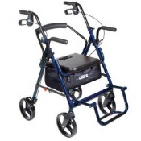  Duet | 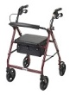  Rollator | 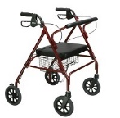  Go Lite Rollator

Wheelchair - Manual
Folding Transport Chair  17-Inch  Weighs only 19 lbs. with 8-inch composite wheels. Back folds down for storage and transport. Standard rear wheel locks.  $142 | Folding Transport Chair  19-Inch  Weighs only 19 lbs. with 8-inch composite wheels. Back folds down for storage and transport. Standard rear wheel locks.  $142 | 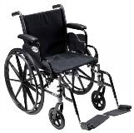  Cruiser III Manual Wheelchair
Wheelchair: Cruiser III  16-Inch  Removable flip back desk arms; carbon steel frame w/silver vein finish. Lightweight Mag-style wheels. Padded nylon seat and back. Your choice of elevating or swingaway legs.  Max weight: 250 pounds. $205 | Wheelchair: Cruiser III  18-Inch  Removable flip back desk arms; carbon steel frame w/silver vein finish. Light weight Mag-style wheels. Padded nylon seat and back. Your choice of elevating or swingaway legs.  Max weight: 300 lbs. $215 | Wheelchair: Cruiser III  20-Inch  Removable flip back desk arms; carbon steel frame w/silver vein finish. Light weight Mag-style wheels. Padded nylon seat and back. Your choice of elevating or swingaway legs.  Max weight: 300 lbs. $220

BARGAIN BASEMENT
Gently used equipment available at ATI in Salem
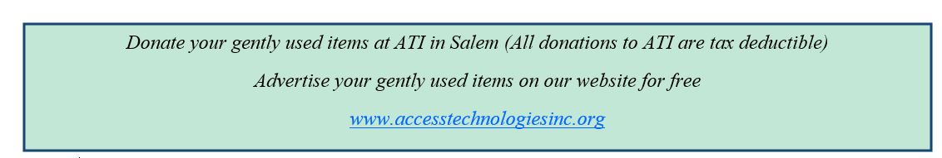
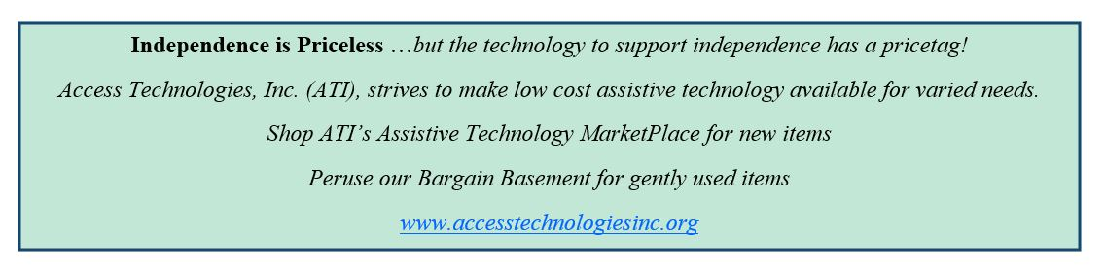
Vision  CCTV $200  Lifts/Transfers  Transfer Board $10  Transfer Sling w/ Handles $10  Transfer Sling w/ Handles $10 | Wheelchairs  Invacare Pediatric Tilt in Space $20  Quickie Iris Transport Chair $100  Quickie Iris Transport Chair $100  Bariatric 20 in. $10  Manual 16 in. (no leg rests) $85  Manual 18 inch $85 | Shower/Bath/Commode  3-in-1 Commode $20  3-in-1 Commode $20  3-in-1 Commode $20  Bariatric 3-in-1 Commode $40.  Bath/Shower Chair $10  Bath/Shower Bar $10
Mobility  Cane (Wood) $5  Hurry Cane $10  Hemi Walker $20  Quad Cane -Large $10  Quad Cane -Large $10 | Mobility  Rollator 6 inch wheels $25  Rollator 6 inch wheels $25  Rollator 6 inch wheels $25  Walker Basket $10  Walker Basket $10  Walker Basket $10 | Wheelchair  Permobile C500 Electric Wheelchair / Stander  Elite power chair with bars and pads to keep person in standing position. with desk.  Without Batteries $150  With Batteries $600
Walkers  Dbl Btn Walker w/wheels $10  Dbl Btn Walker w/wheels $10  Dbl Btn Walker w/wheels $10  Dbl Btn Walker w/wheels $10 | Walkers  Dbl Trigger walker w/wheels $20  Dbl Trigger walker w/wheels $20 | Walkers  Single Btn walker w/wheels $20  Non-Folding Walker $10

(Fidgets - continued from page 2)
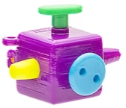
The Squidget is a small light weight fidget that is designed to attach to the end of a pen or pencil. It is designed to address several of the most common fidgeting documented such as button spinning, pen rolling, (hair) twirling, and rubbing textures. Each side of the cube features a different element.
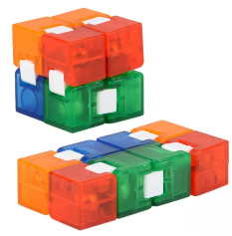
An Infinity Cube is a mathematical puzzle toy that consists of 8 blocks attached together that can be folded around and on top of each other. It can be opened and arranged in different shapes and from different directions creating an interesting visual effect. Infinity Cubes can even be used one handed.

Magnetic sculptures use a magnetic base and non-magnetic media to create moldable sculptures. The media can be shapes (such as balls, stars, moons), letters or objects like snowflakes, people or nuts and bolts.
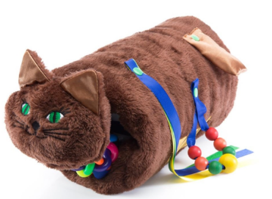
Twiddle Muffs are machine washable fidgets designed for individuals with dementia. There is a stuffed dog and cat version, or a sport version with plaid fabric. They feature gadgets such as ribbons, wooden beads, pockets, Velcro and a squeezy ball to keep restless hands busy. Restless hands are common if the individual performed manual tasks with their hands before the onset of dementia.
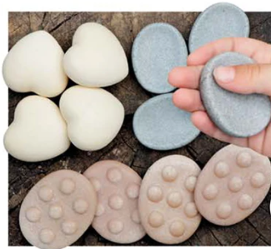
Finger Fidget Stones are discrete natural-colored stones that provide a tactile sensory experience. These provide the user with a smooth relaxing experience to relieve anxiety and calm nervous energy. They come in packs of 12 with three shapes: heart, knobby and hollowed.
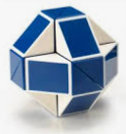
Rubik’s Snake (also Rubik’s Twist or Rubik’s Snake Puzzle) is a mechanical toy made of triangular prisms that can rotate freely (but not come apart) to create an infinite variety of objects and geometric shapes including cubes, triangles, hearts, dogs, turtles, and so much more.
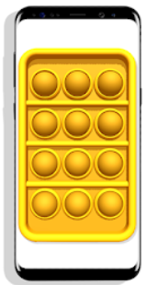
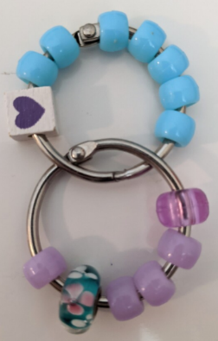
Applications (apps) such as the Sensory Fidget Toys Game! turn a smartphone or tablet into an anti-stress and anti-anxiety device. This app contains virtual fidgets including Pop Its, Fidget Cubes, Magnet and Squish Balls, spinners, gears, slime, and more, for hours of immediate stress relief and focus relaxation.
Fidgets don’t have to be costly. DIY and 3D printed fidgets are on the rise. A simple DIY fidget can provide hours of spinning, rolling and more can be made with Binder Rings and Pony Beads. Sand can be placed in an empty balloon and tied off for a quick and easy fidget squeezer. Glitter, distilled water and glue can be added to a water bottle for a calming fidget. The possibilities are endless.
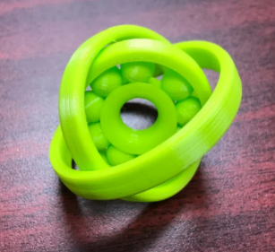
Online 3D printing instruction websites like Instructables and Thingiverse host STL files that act as blueprints for making a wide variety of fidgets. From fidget spinners and rings, to slinkies, widgets and gyroscopes, files are open source and readily available.
Fidgets really do serve a valuable purpose. Researchers are working toward inventing the next generation of fidgets to provide just the right level of stimulation while keeping calm and managing attention.
Join Our Team!
Have you dreamed about a job where you help people find solutions to physical, mental, sensory, and emotional challenges?

We are recruiting for an Assistive Technology Specialist.
On the job training is available.
Job descriptions are available under the “Join our Team” tab on our website (accesstechnologiesinc.org) or send an email inquiry to info@accesstechnologiesinc.org.

