Tech It Easy

August 2018 Edition
Editor: Laurie Brooks
Access Technologies, Inc.
Inside this Issue:
Exploring AT Hand Tools | 1
Tools4Troops | 1-2
Crossover Vise System | 2
ATM — MarketPlace | 3-7
iCanConnect-Oregon | 8

Exploring Assistive Technology Hand Tools

Are you struggling with a home improvement or gardening project because you have not found the right hand tool to accommodate your injury or disability? There are many different types of hand tools on the market including some designed with large displays, auditory beeps or braille and large print numbers. Like all assistive technologies, figuring out which tool, or tool design is right for you, can be challenging, but there are resources to help. For instance, did you know that the Lending Library at Access Technologies, Inc. has a variety of adaptive hand tools including hammers, pliers, grips, and levels? The Library also includes long handle gardening tools, as well as helpful automotive devices too!
So before you spend hours, walking up and down your local tool store, peruse ATI’s online Library (www.accesstechnologiesinc.org), or give our AT Specialists a call (503.361.1201), they will be pleased to talk about tool accommodations with you. You might even want to borrow a tool or two to try on your next honey do project.

Tools4Troops

Are you a veteran looking to complete a home project, but need a few tools to get the job done, or do you need tools for your job? Would you be able to change employment or receive an advancement in your career if only you had the right hand or power tools? Perhaps Tools4Troops can assist. Their mission is to support veterans and service members of the five branches of the U.S. Armed Forces with all types of hand and power tools. Qualified individuals may receive tools as a gift or on a no cost loan basis. Along with tools, the organization also provides safety instructions, product manuals, and specialized training where applicable.
Tools4Troops is a 501(c)(3) nonprofit, and as such they accept new and used tool donations, which in turn, are distributed to veterans who … simply ask. Sometimes the tools help veterans obtain employment, or in the case of one Army veteran highlighted in their newsletter, who not only received a carpentry job, he was offered a higher starting wage because he had his own tools – tools he had recently received through Tools4Troops!
Visit their website www.tools4troops.com for more information.

Crossover Vise System
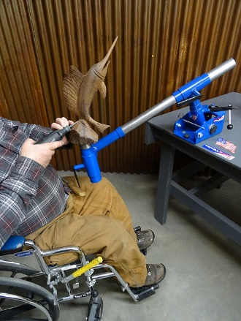
Working from a seated position in your shop just got easier with the Crossover Vise System. Place the vise on your workbench, lock the articulating arm in place, and you are ready to work on your wood carving, small engine, or almost any other project that requires it to be mounted and secured in place.
It will easily and safely hold almost anything in a variety of working positions. For instance, it can tilt from left to right, or up and down and then be locked into place to maintain proper positioning. It is designed to be efficient and easy to use, and is a space saver as well; small enough to fit in most storage cabinets with ease.
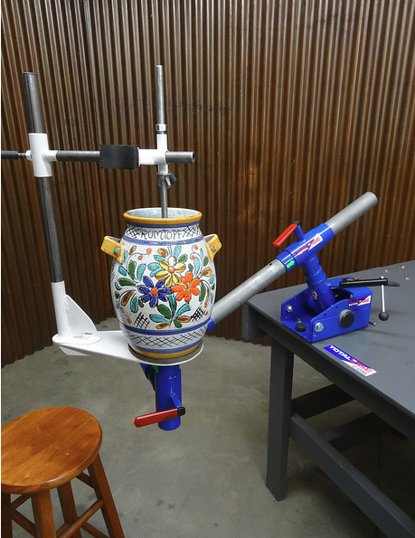
The Crossover Vise System comes in a variety of work station packages, including the wood carving package shown above, or if you’re an artistic individual and love to paint the Artist Easel or Art Base Plate package might be right for you. Other packages are designed to accommodate welders and small engine workers too, just to name a few.
More information is available online at www.totalvise.com or by phone at 406.830.5881.

