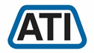 | Tech It Easy | Access Technologies, Inc.  May 2019 Edition  Editor: Laurie Brooks

Inside this Issue:
DME Reutilization | 1, 10
Board Recruitment | 2
ATM - MarketPlace | 3 - 7
Bargain Basement | 8 - 9
iCanConnect-Oregon | 12

Should You Buy Refurbished Equipment?

When you are in the market for a bedside commode, wheelchair, or other durable medical or assistive equipment, you may wish to consider purchasing a gently used one.
As part of Oregon’s Statewide Assistive Technology Program, Access Technologies, Inc. (ATI) has been refurbishing gently used durable medical equipment (DME) and assistive technologies since 1991.
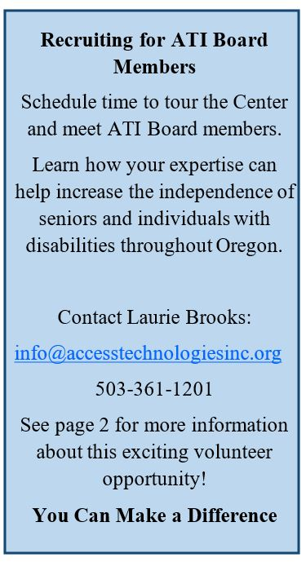
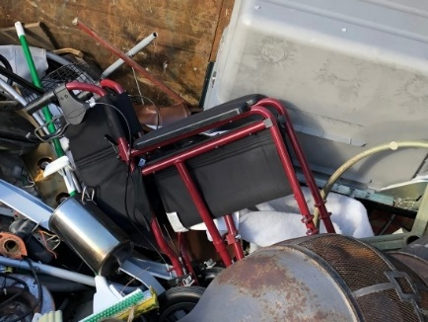
Along with other reuse organizations across the nation, ATI helped refurbish over 68,500 devices in 2018. These devices saved individuals and families more than $26,500,000! Typical refurbished equipment includes donated power wheelchairs, patient lifts, and bath chairs, as well as, older laptop computers and iPads that have been moved out of our lending library.
Discarded transport chair
Here are some reasons to consider refurbished equipment.
  - Reuse fills the gap when Oregonians are unable to obtain new devices they need.
  - Reuse saves money for the person using the equipment.
  - Reuse saves health care costs by preventing secondary disabilities that would have developed without it.
  - Reuse keeps usable equipment out of the landfill.
  - Reuse ensures efficient and effective use of Oregon’s communities by using equipment to its full potential.
(Continued. on page.10 - Reuse)

Help Guide Our Dynamic Organization into the Future!

Access Technologies, Inc. (ATI) is looking for a few energetic, forward thinking individuals with business, non-profit or legal expertise to join our volunteer board. We meet three times a year, for two hours, on the second Wednesday during the months of March, September, and December.
The Access Technologies, Inc. Board of Directors is composed of leaders who are dedicated to ATI’s mission. Serving on the Board is an extraordinary opportunity for an individual who is passionate about ensuring individuals with disabilities are able to gain and maintain independence through the use of assistive technologies.

What’s in it for you
As a member of ATI’s governing Board of Directors you will become an integral part of the project’s decision-making process, as we look to our next 25 years! This position will give you a chance to increase your awareness of state of the art assistive technology accommodations which provide individuals with all disabilities the opportunity to contribute to a meaningful and fulfilling life.

What costs are involved
This is a volunteer position. ATI will cover all your travel, accommodation and meal expenses as set out in our Expense Policy. Meetings will be a combination of conference calls and in-person meetings in the Salem area.

Time commitment
The first term is for one year. Thereafter all members of the Board of Directors shall be elected for a two (2) year term.

The Election Process
In keeping with ATI’s By-laws/procedures, all nominations will be screened by the Nominations Committee based on past experience relevant to the current needs of the board, and their experience and/or commitment to working with individuals with disabilities.

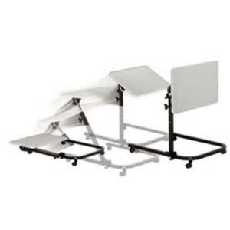
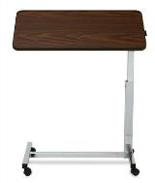
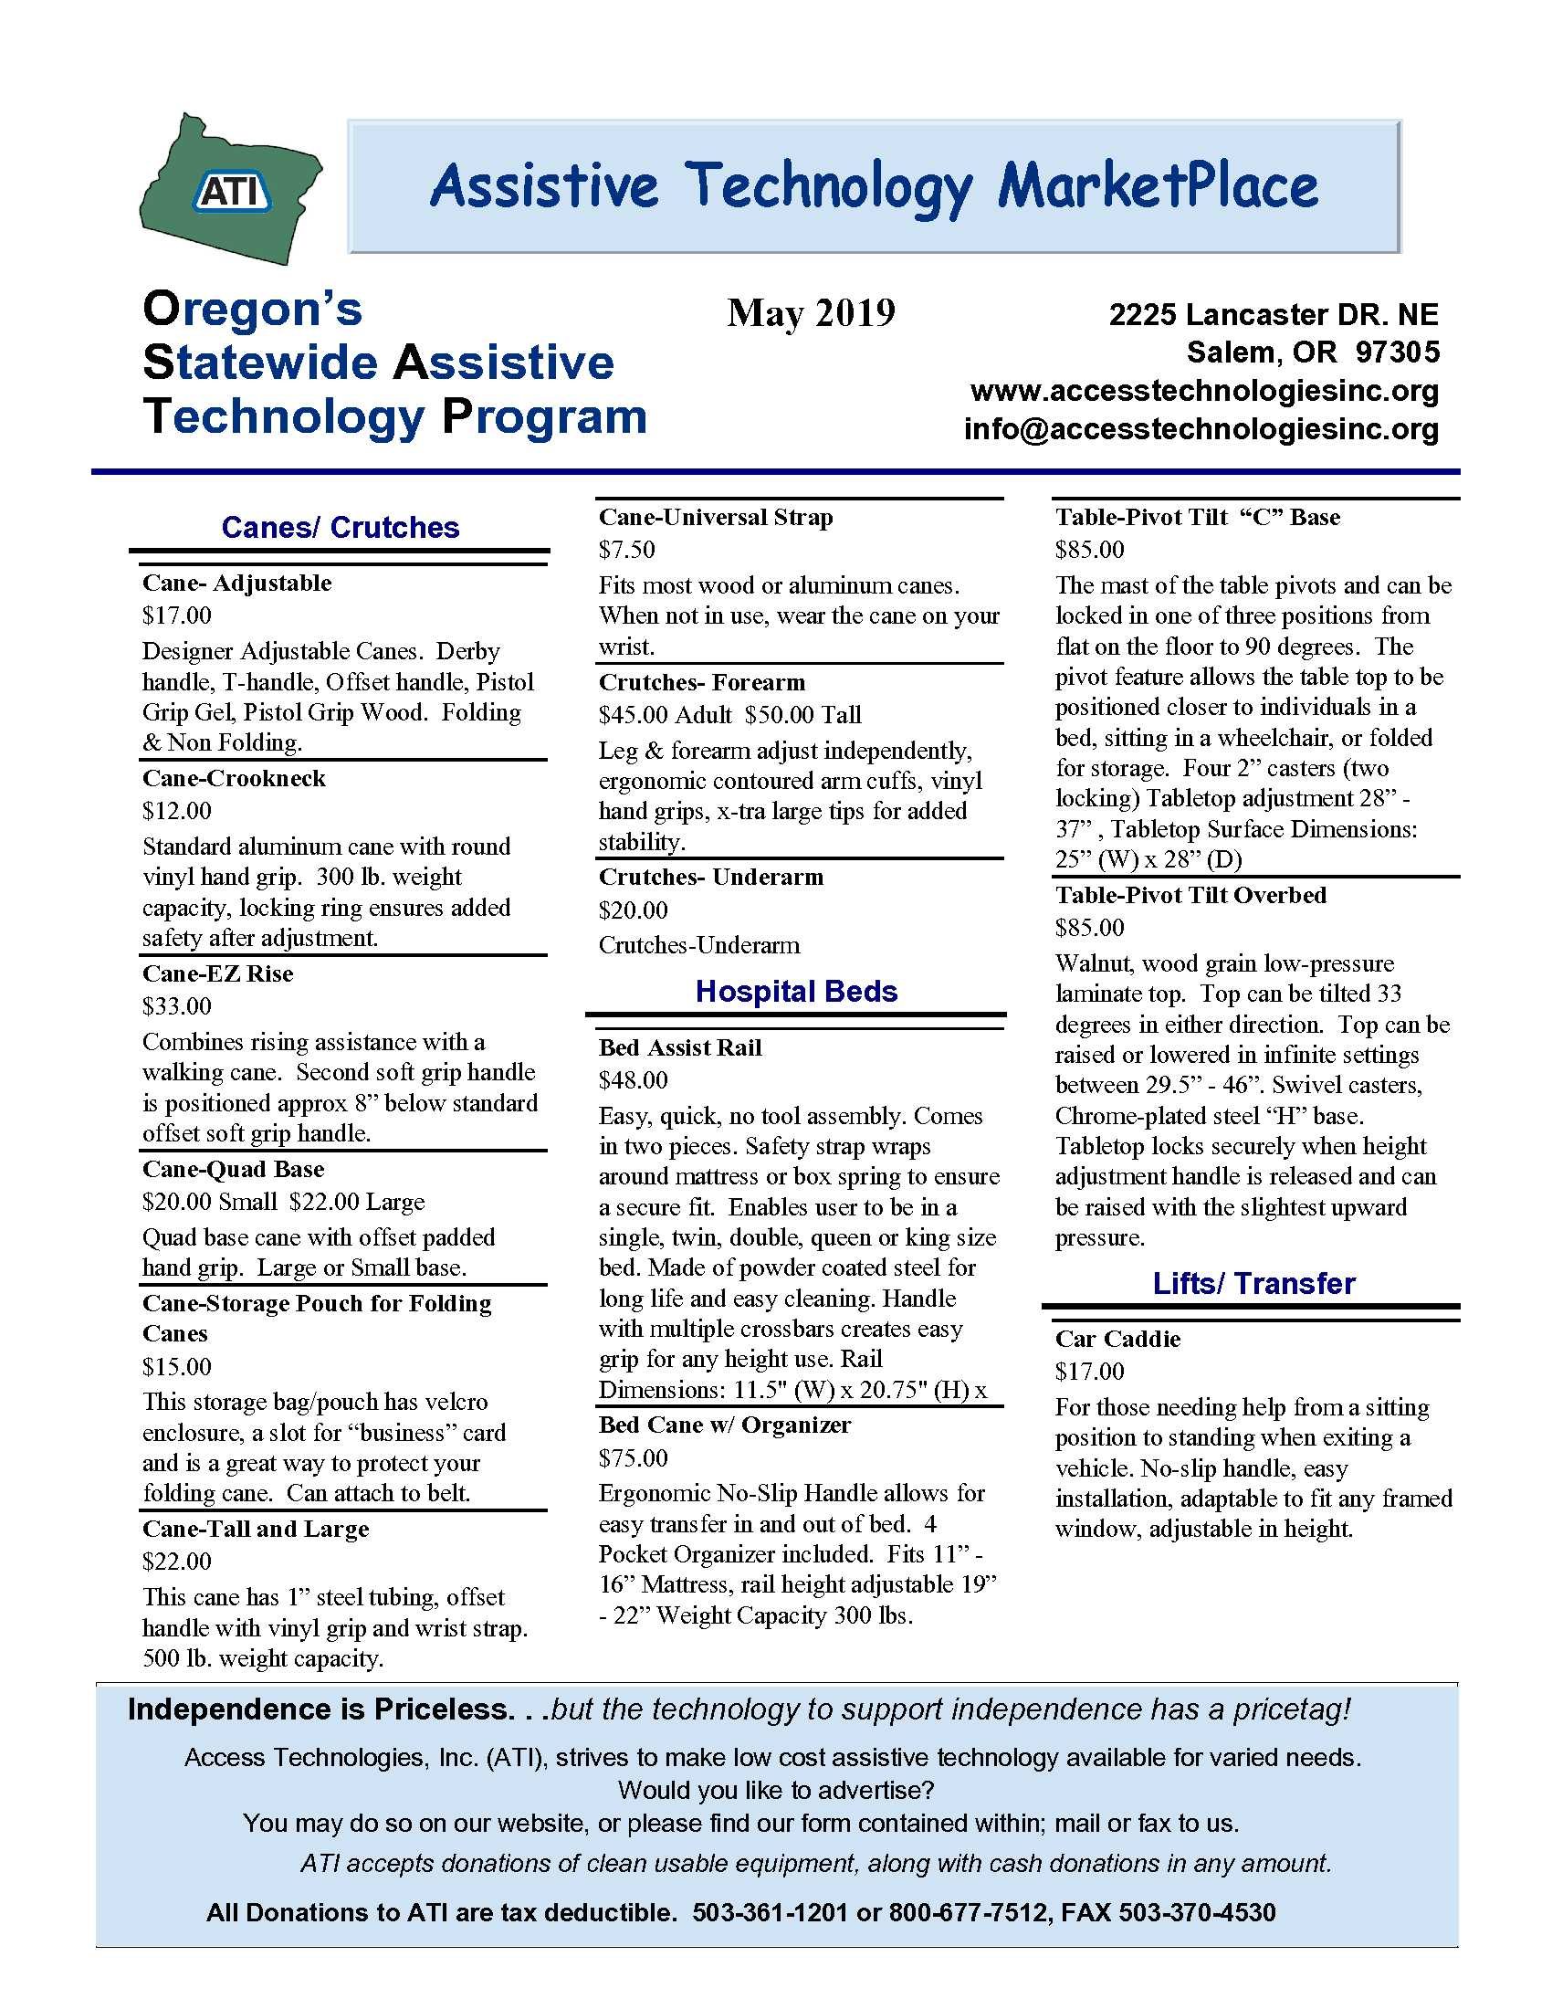
Overbed Table Pivot Top
Overbed Table Pivot Tilt – C Base

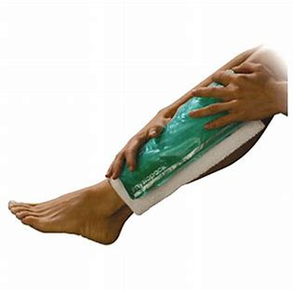
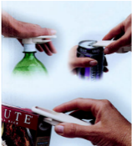
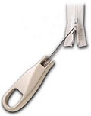
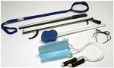
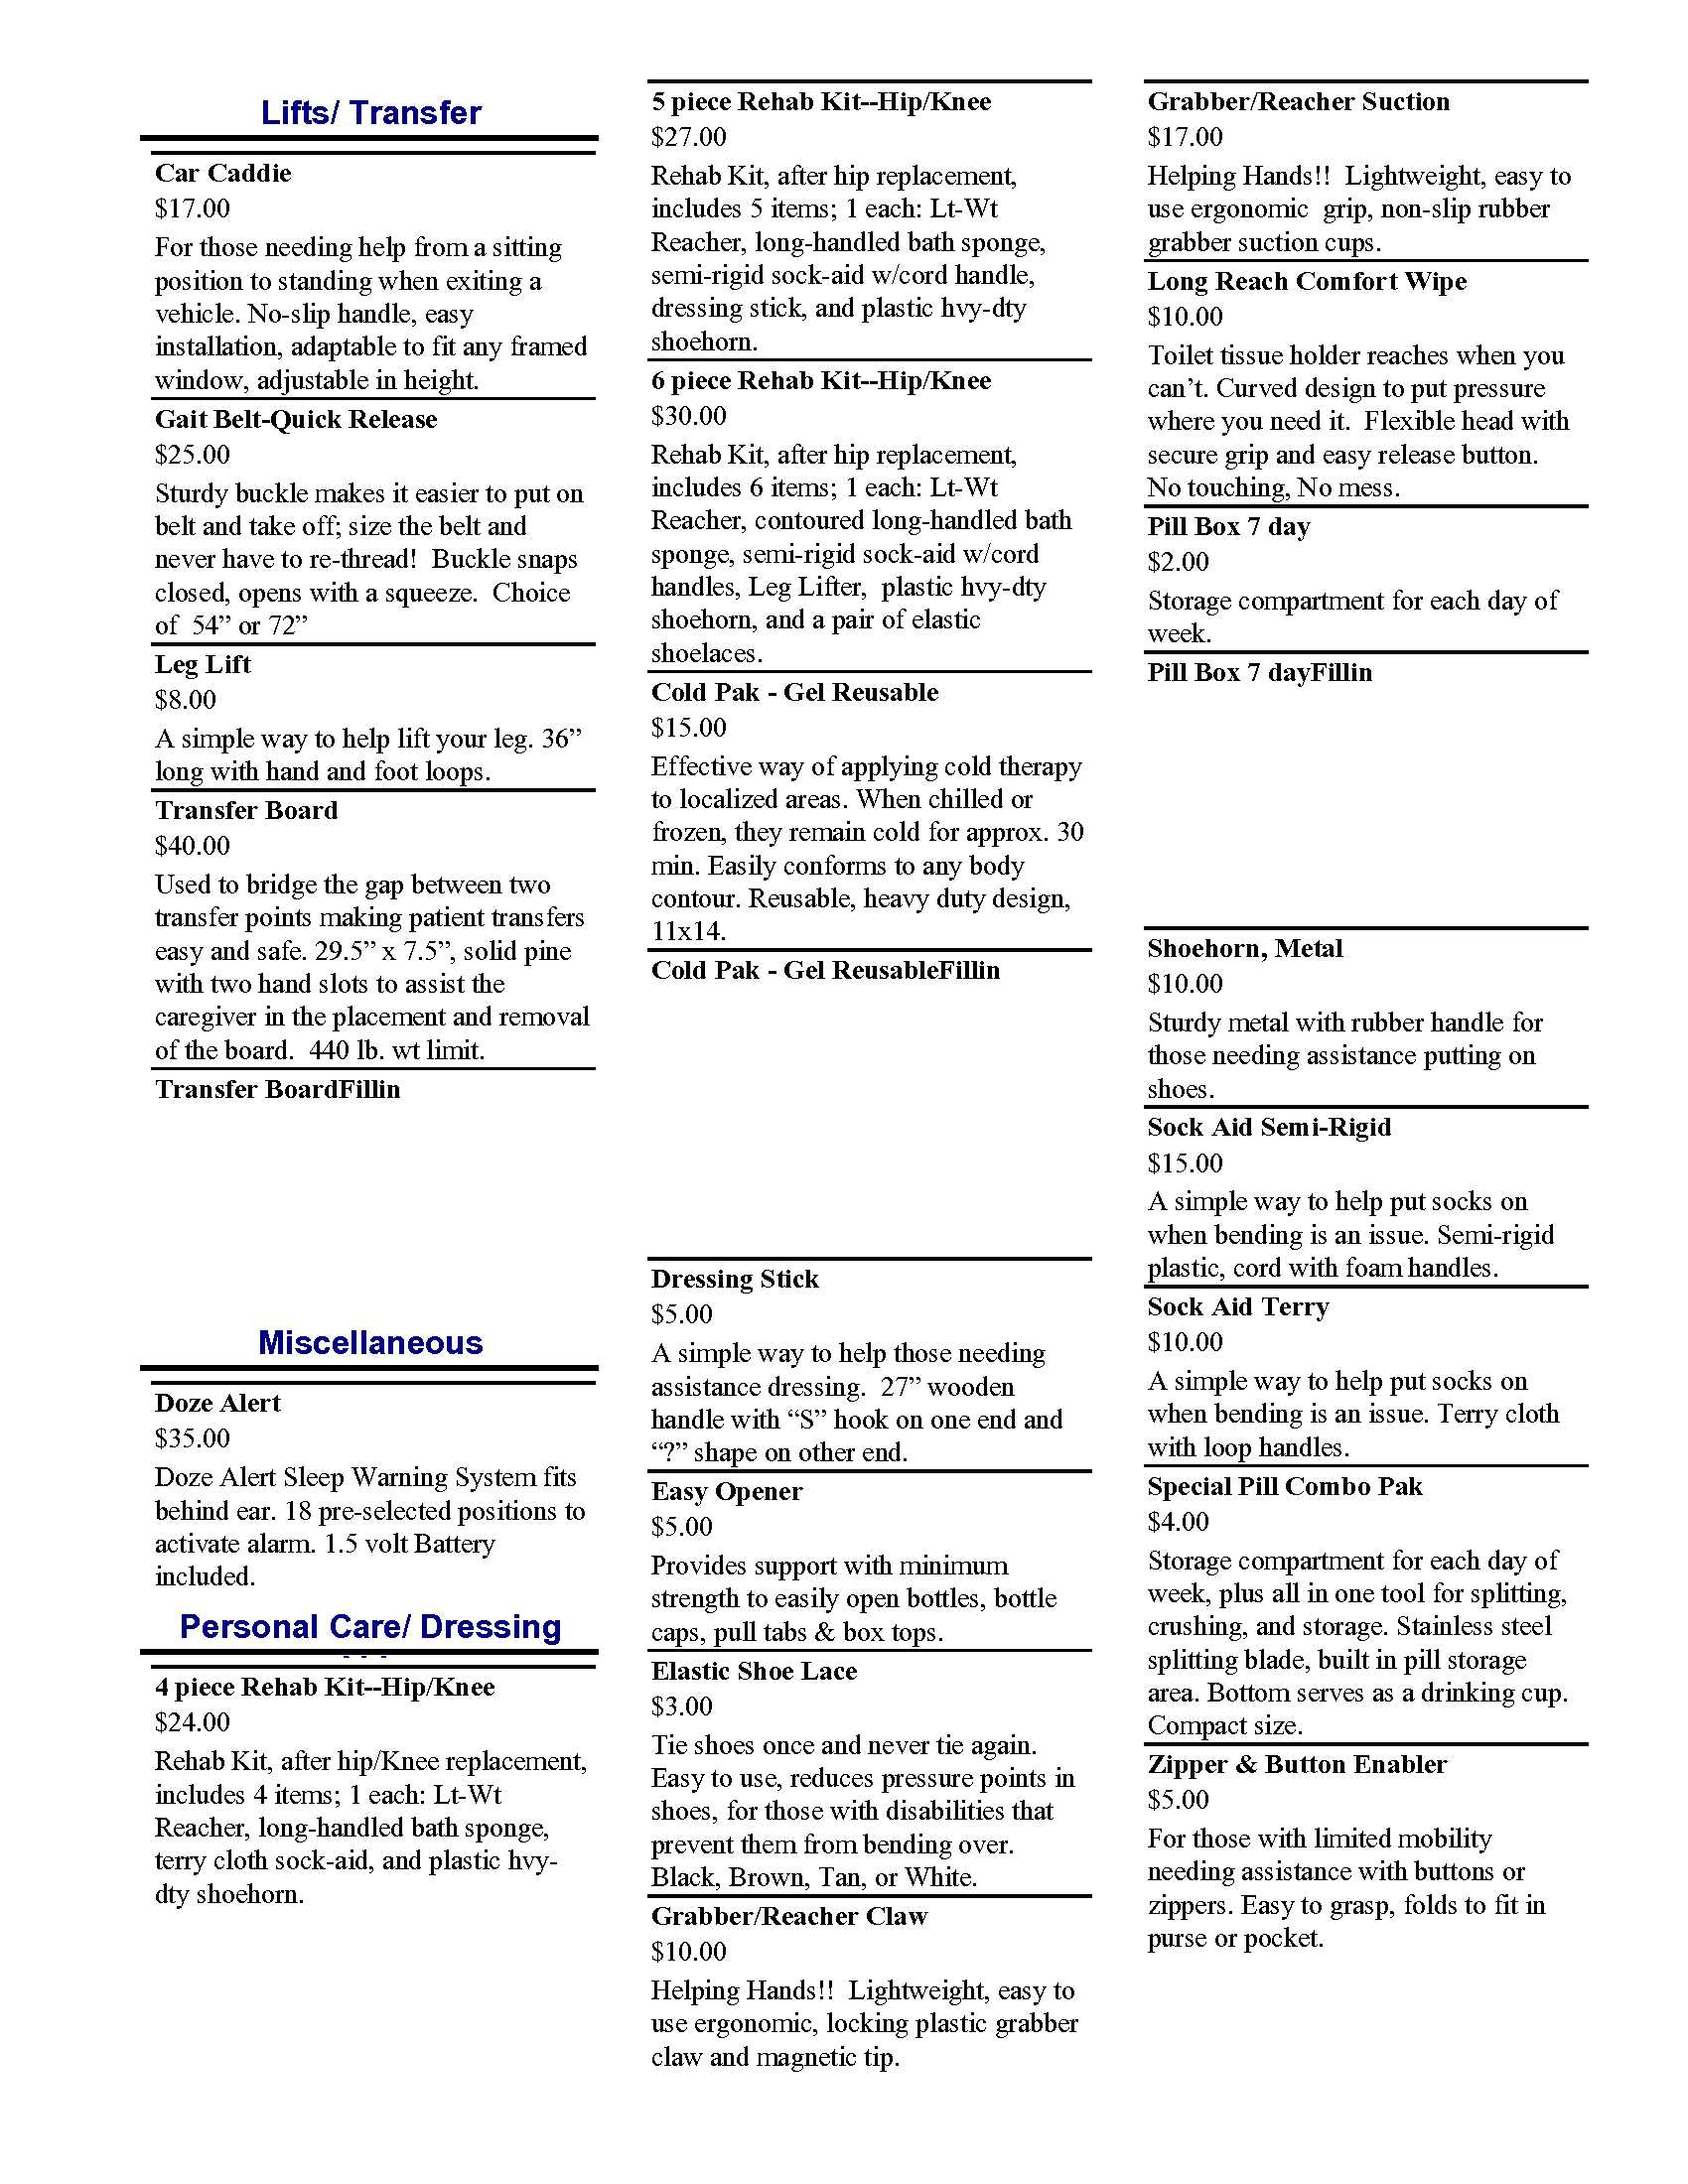
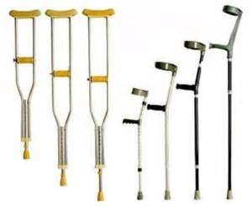
Gel Cold Pak
Enabler Easy Opener
Button/Zipper Pull
Leg Lifter
Transfer Board
Six Piece Rehab Kit
Crutches
Six Piece Rehab Kit

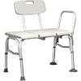
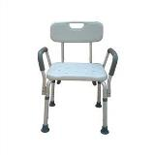
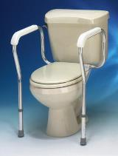
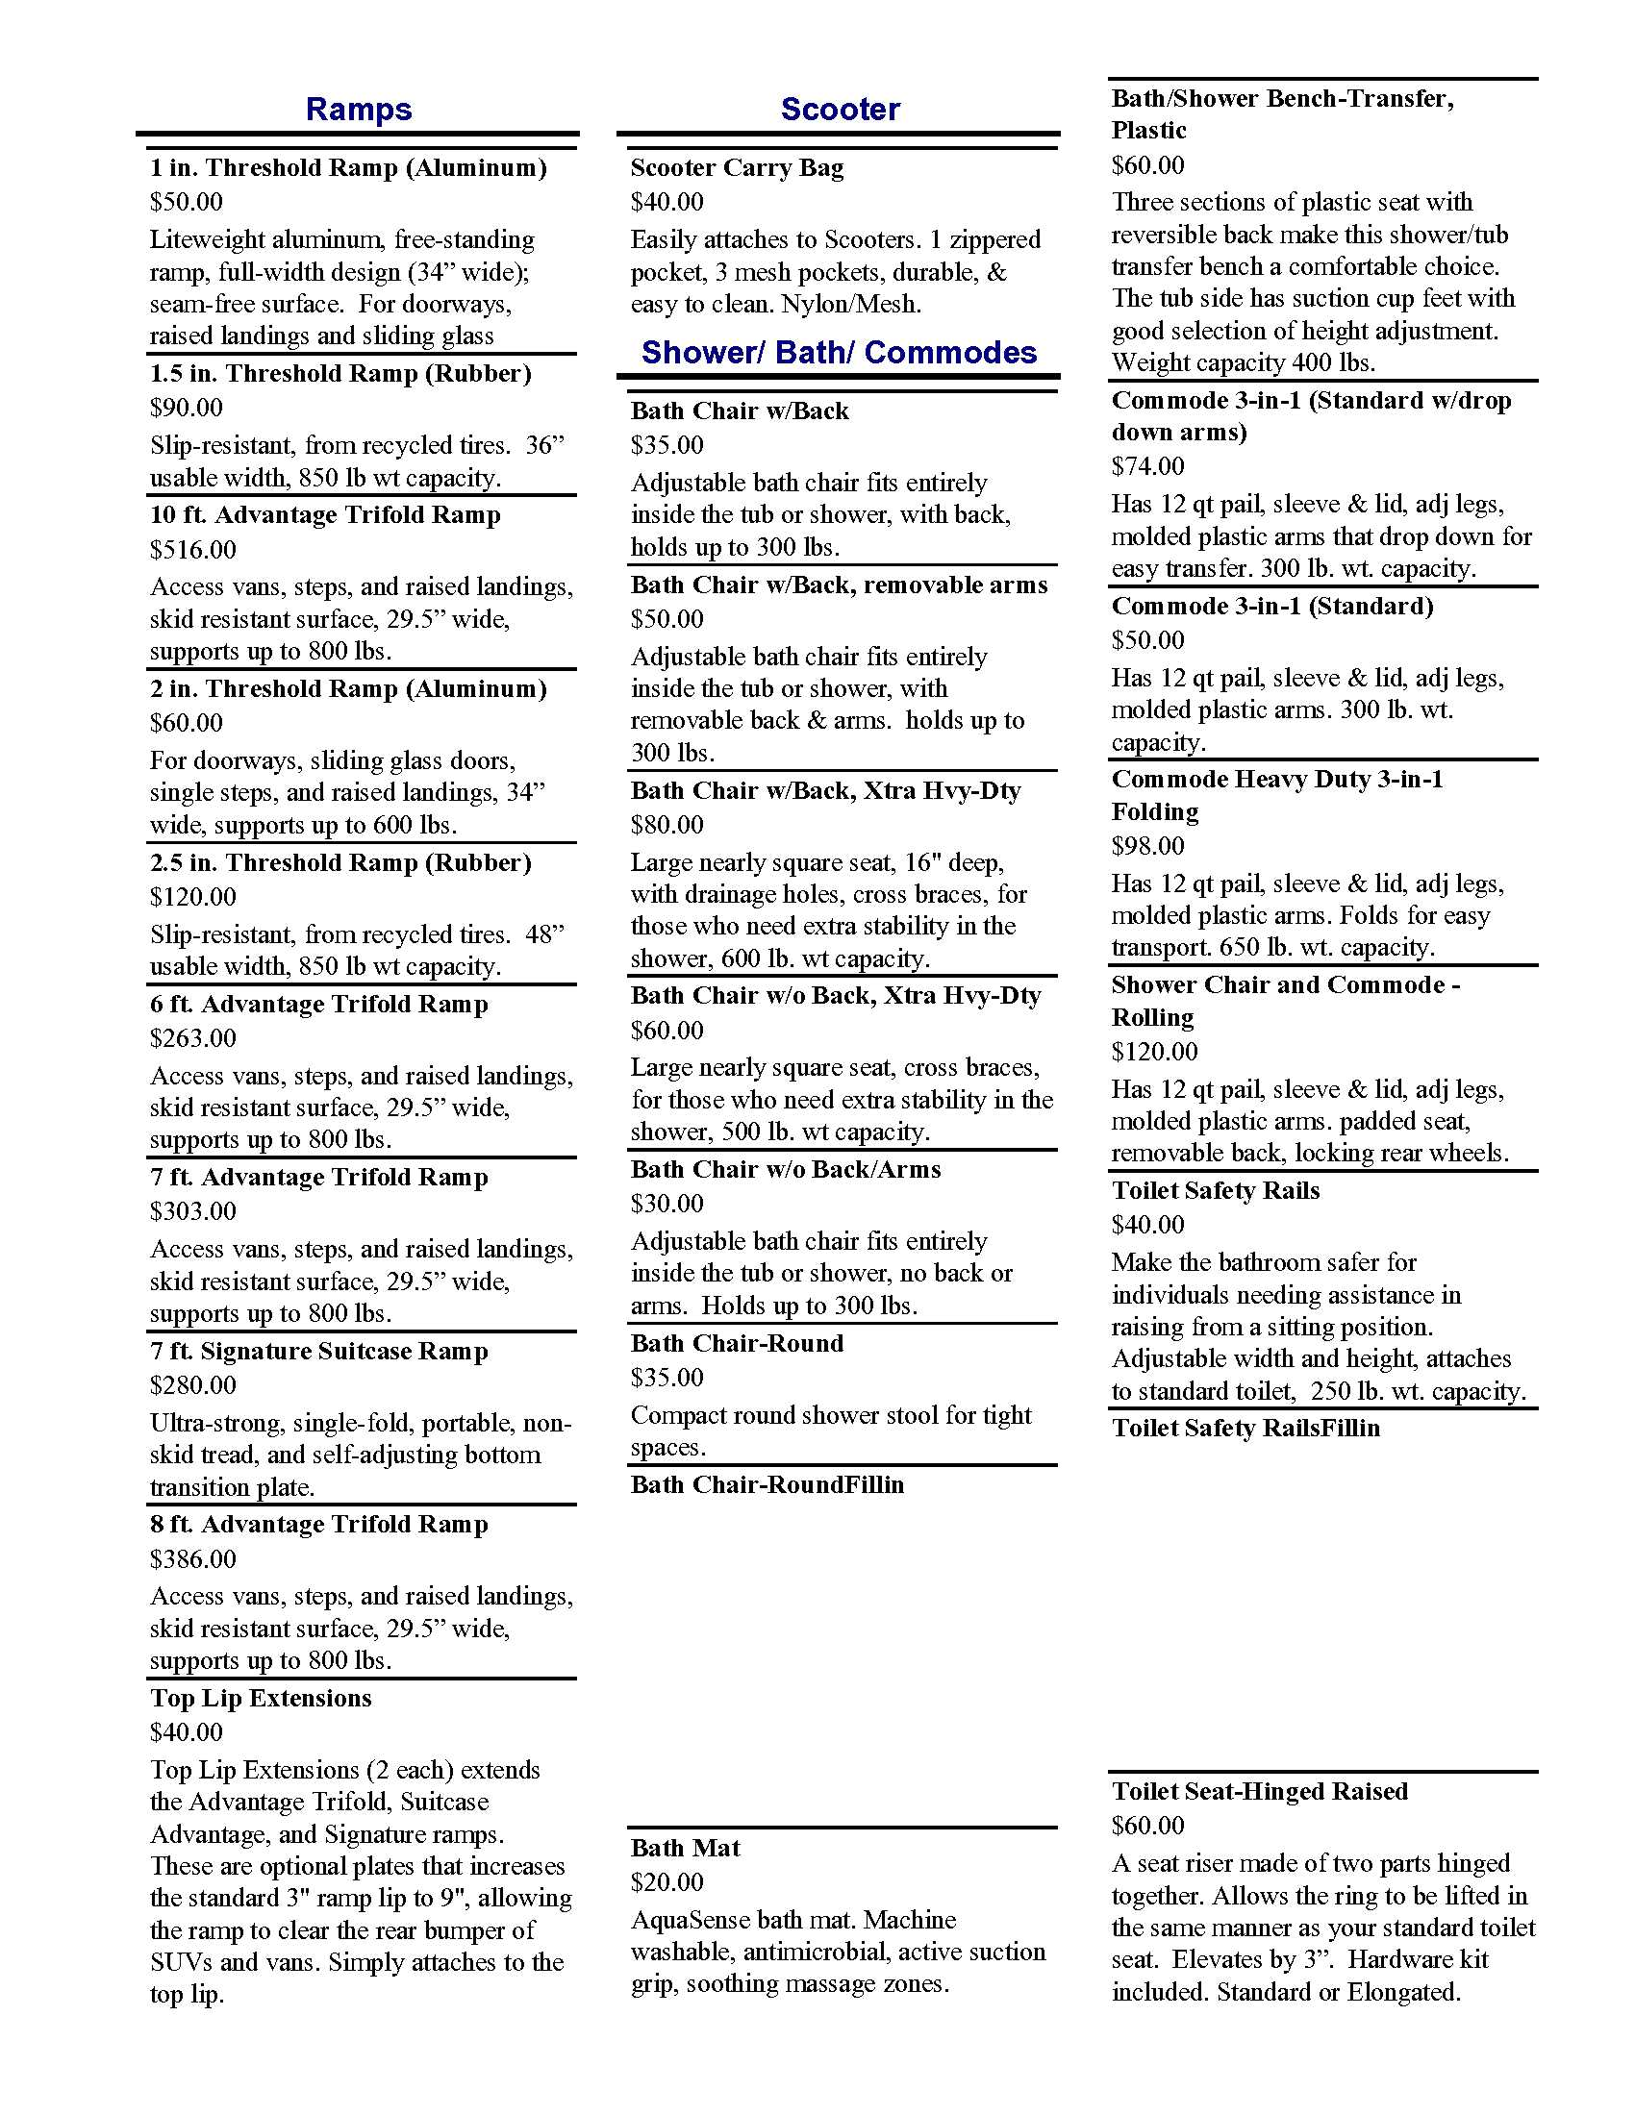
Bath Transfer Bench
Bath Chair
Toilet Safety Rails

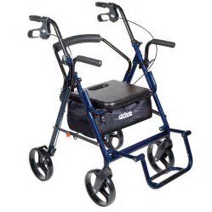
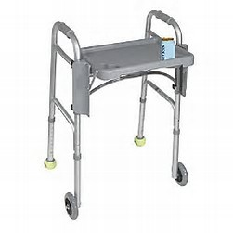
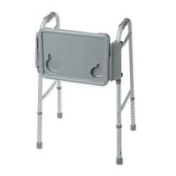
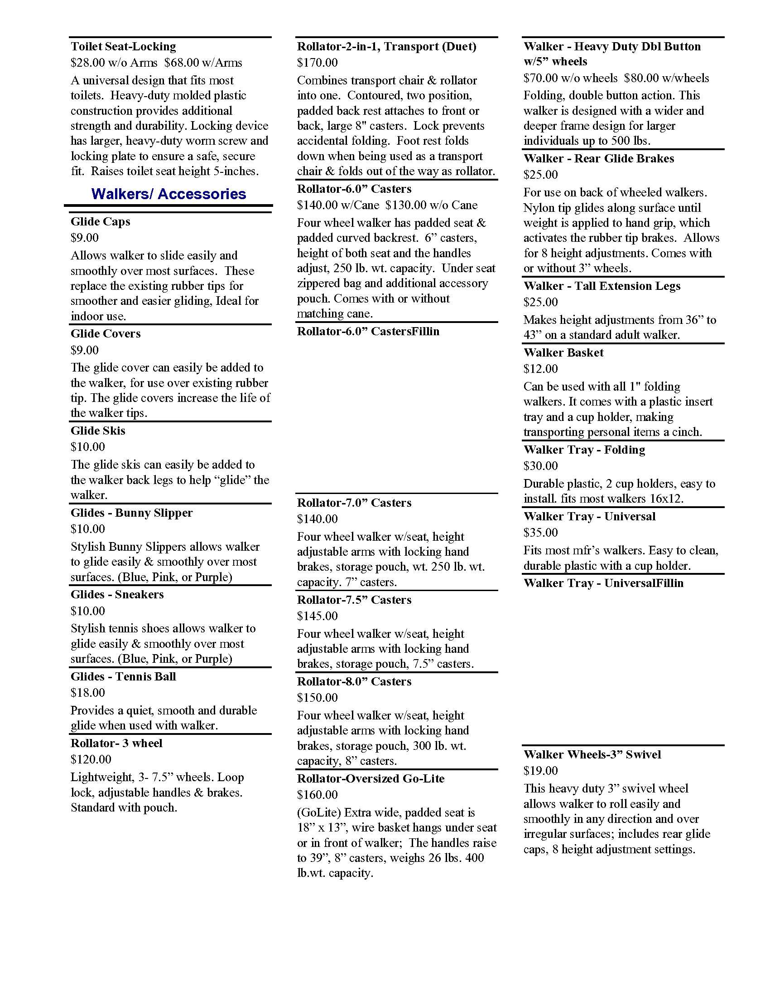
Duet
Universal Walker Tray
Folding Walker Tray

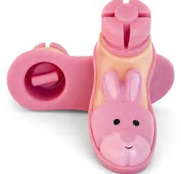
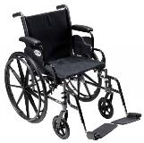
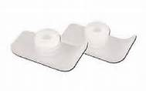
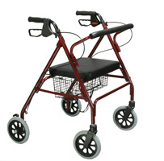
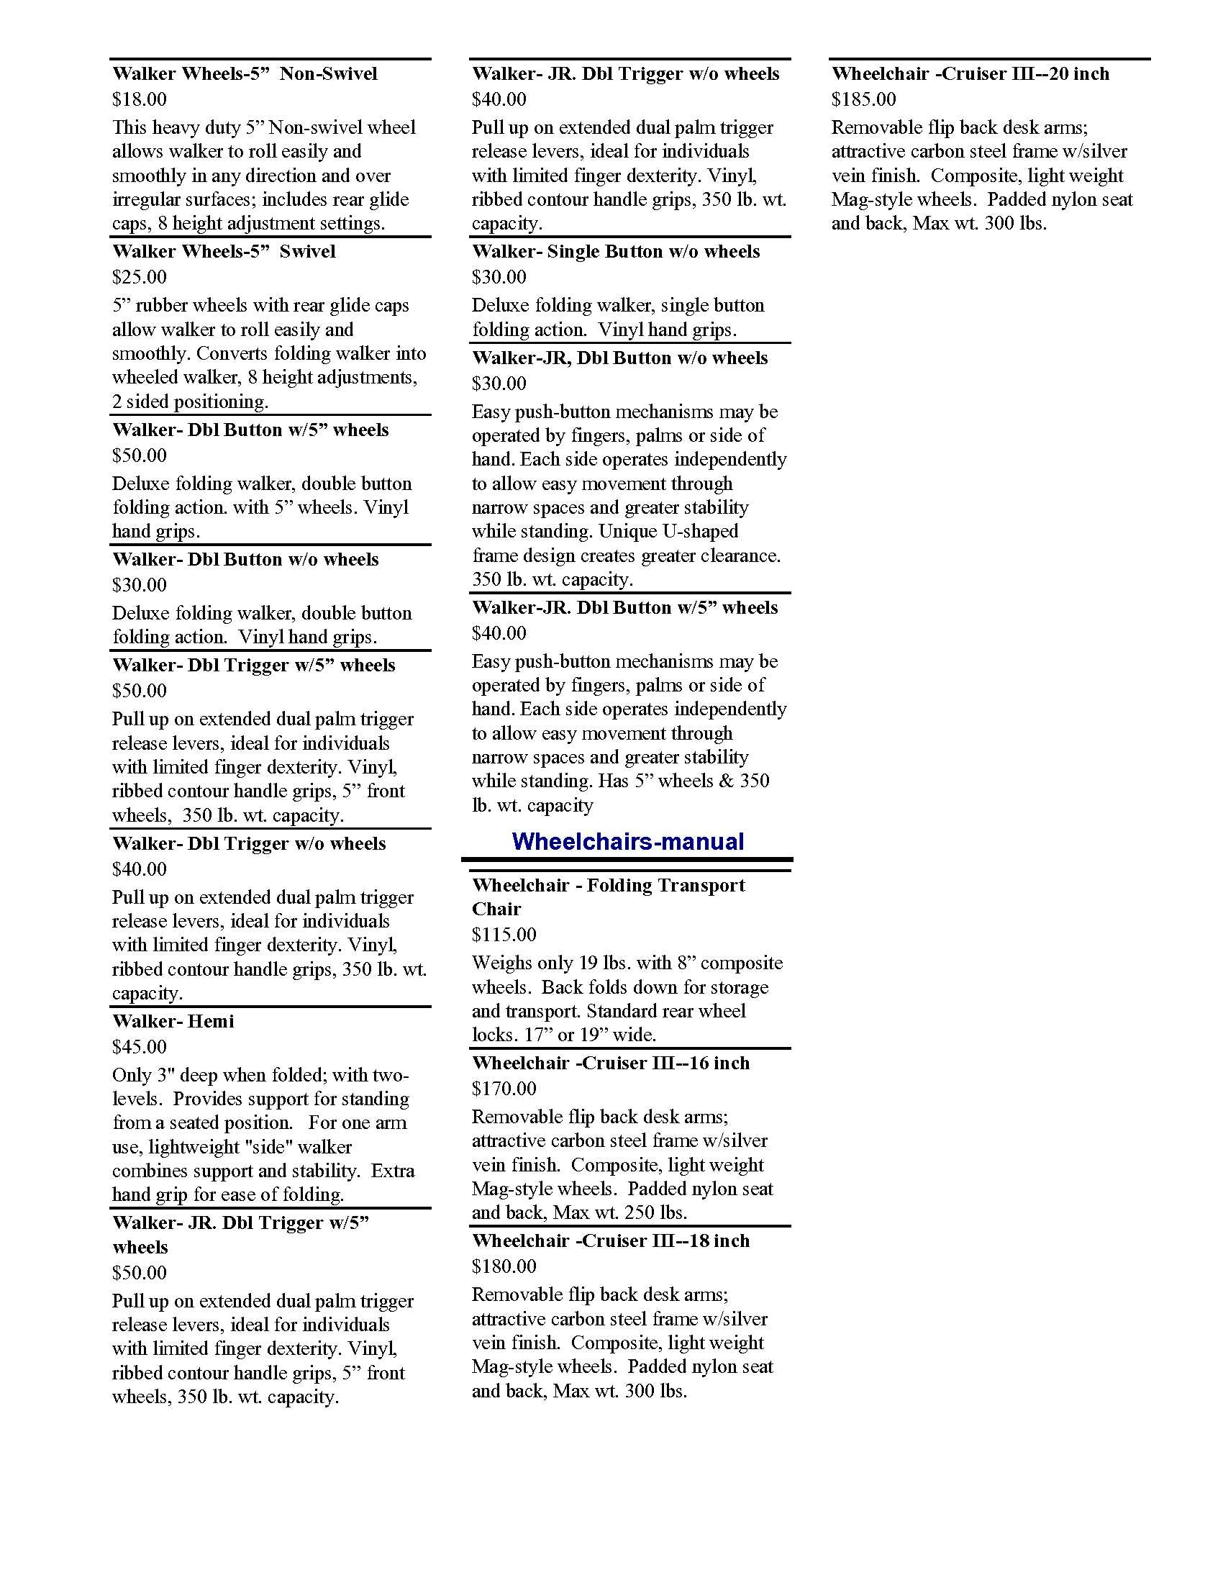

Glides
Bunny Slippers
Cruiser III Manual Wheelchair

Glide Skis
GoLite Rollator
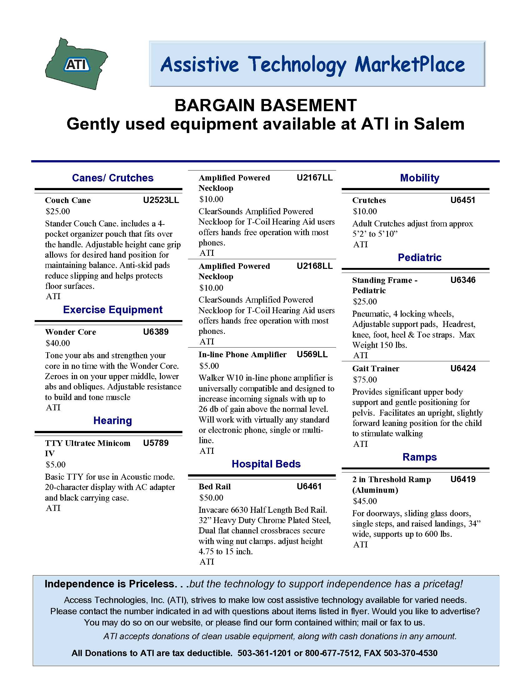

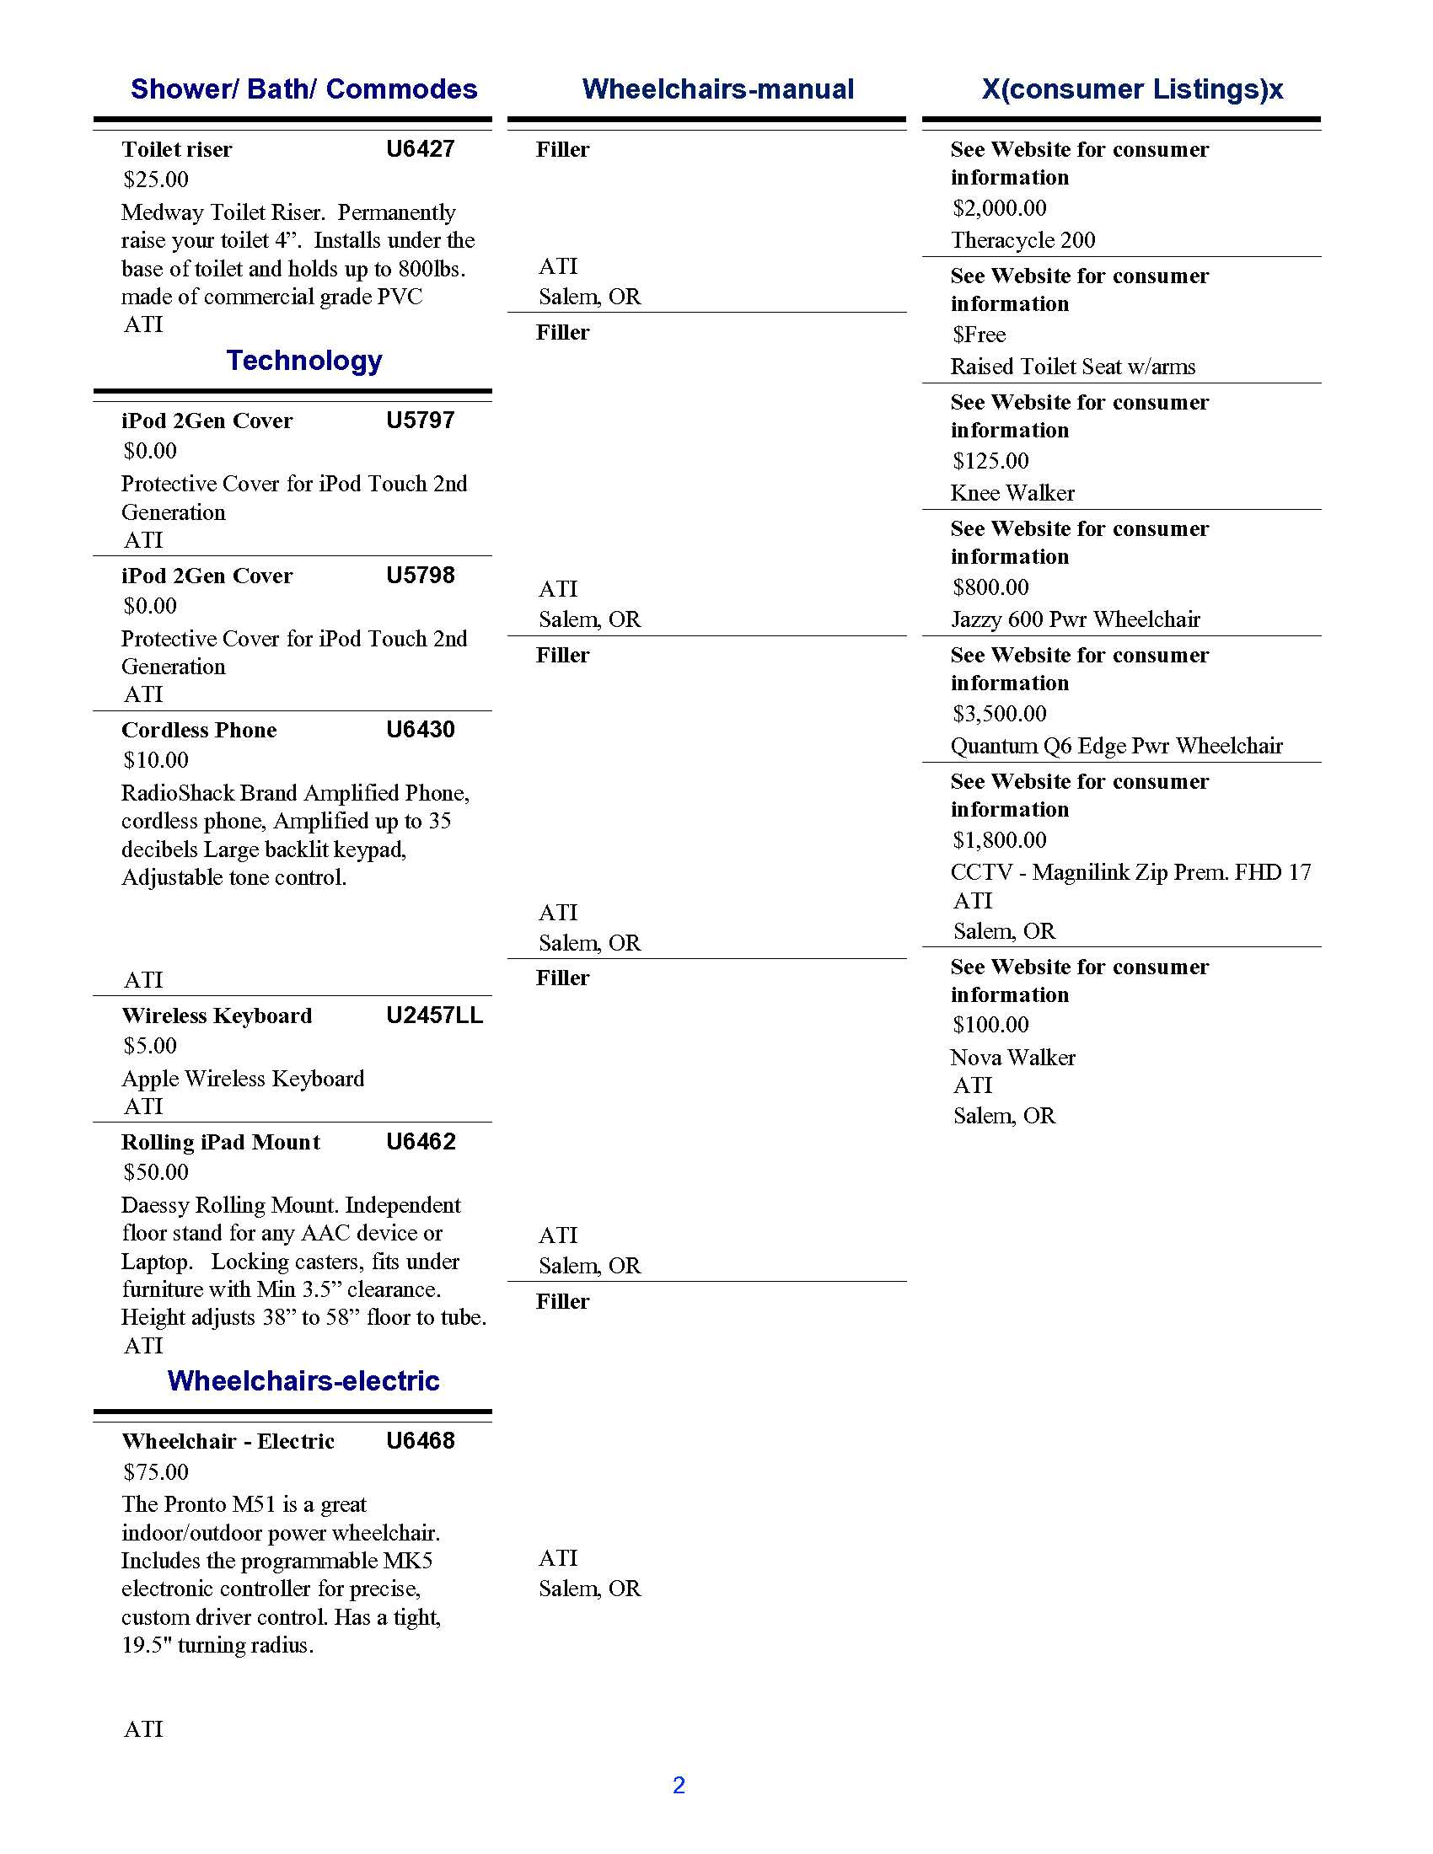
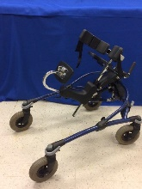
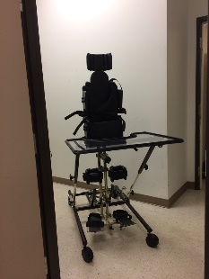
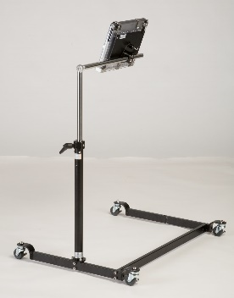
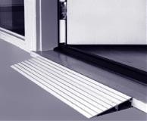
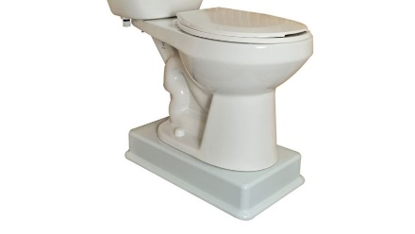
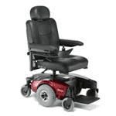
Pediatric Mustang Gait Trainer
Standing Frame
iPad Mount
Threshold Ramp
iPod Cover
Toilet Base Riser
Pronto M51
MagniLink Zip
Consumer Listings
Pictures of Used Items

Consumer Listings

Wireless Keyboard
Knee Brace
iPod Cover
Threshold Ramp
Standing Frame
Consumer Listings

(Reuse - continued from page 1)
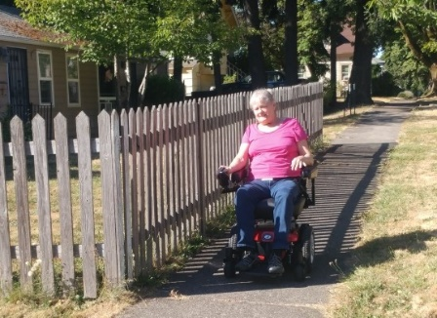
Staff at ATI enjoy being able to save individuals money while also saving the environment. Susi, shown here, saved over $4,500 by selecting a refurbished power wheelchair through ATI’s Marketplace last year. That’s a great feeling for all involved, but did you know that governmental and nonprofit reuse organizations, including ATI, face challenges similar to commercial businesses?
These agencies and organizations must comply with legal and regulatory issues related to the equipment, and have specific cleaning and refurbishment policies and procedures in place. Therefore, for your health and safety ATI’s process for getting gently used, durable medical equipment into the hands of those can benefit, is a little involved.
Refurbishing equipment includes accepting donations, sanitizing, conducting minor repairs, and then making it available to those who have a need for these items. The donations of equipment can occur for many reasons. A child may outgrow the equipment, a loved one may have passed away, or an individual's condition may change and the items are no longer appropriate for the user.
“For people without disabilities, technology
makes things easier.

For people with disabilities, technology
makes things possible.”
ATI’s refurbishment best practices are designed to prevent transmission of diseases that are caused by microorganisms, including cold and flu viruses which can survive up to 72 hours on solid surfaces. Therefore, our cleaning, disinfecting, and sanitizing processes and procedures are specific to each type of equipment.
Additionally, ATI’s policies for refurbishment or repairs prohibit altering devices from the original manufacturer specifications, and requires repairs and refurbishments to be completed by qualified technicians, using appropriate replacement parts. Furthermore, our guidelines prevent the redistribution of any equipment recalled by the Food and Drug Administration.
Look for refurbished equipment at our storefront, inside Tech It Easy, or on ATI's Marketplace (www.accesstechnologiesinc.org).
In addition to ATI, there are a number of retail and non-profit organizations that provide refurbished equipment for much less than you would pay for at an online retailer or through your local pharmacy. Here are a few local organizations
- The ALS Association Oregon and SW Washington Chapter online at www.alsa.org.
- The McMinnville Lions Club can be reached at 503-435-5466.
- The Muscular Dystrophy Association online at www.mda.org.
Please remember, for your health and safety, ask your reuse organization about their refurbishment Best Practice Policies

Have gently used equipment to donate
ATI accepts most devices that assist a person with a disability to live more independently or safely. For the integrity of the Program donations must be legally owned by the donator, clean and in working condition. For the health and safety of our customers, ATI does not accept donations of devices which
- state for prescription use only
- require supervision of a medical professional for purchase
- pose hygiene or safety risk (ie ventilators, oxygen equipment, catheters, etc.)
- are subject to warnings, bans, or recalls issued by the FDA
Due to limited staff resources ATI prefers donations are delivered to our office. However, whenever possible, staff will coordinate the pickup of items when working in your area.

A Resource to sell your gently used equipment
ATI also maintains a FREE online classified service available to people with disabilities, their families, friends, service providers, and others who want to buy, sell, or donate their gently used DME and AT. The program is designed to facilitate equipment exchange between individuals and is not intended for the use of vendors or distributors. These classified ads are included in ATI's Marketplace (www.accesstechnologiesinc.org)
If you have questions about any of ATI’s Reuse services, would like to donate equipment, or request assistance placing an advertisement, call our office at 503-361-1201.

