 | Tech It Easy | Access Technologies, Inc.  October 2019 Edition  Editor: Laurie Brooks

Inside this Issue:
Filling the Backpack | 1 - 2
ATM - MarketPlace | 3 - 7
iCanConnect-Oregon | 8

Back to School with ATI:

Filling the Backpacks with the Right Stuff

(by Susan McNaught, ATI Board Secretary/Treasurer)
The weather is still warm but we know the crisper weather is coming. Teachers have worked hard to get classrooms ready. Eager kids have poured into those classrooms and parents have shopped for all the stuff kids need to go back to school. The backpacks are full -- well they were full on the first day.
For families who have children with special needs, the backpack stuff includes more than crayons, glue, and notebook paper. It might include assistive technology (AT). Okay, some of the AT might not actually go into the backpack, but it could be just the ticket to make sure the school year goes smoothly for your child.
The beginning of each school year brings excitement and anxiety. Excitement that there are new opportunities to learn (and the kids are back in school!!), and anxieties that the kids may struggle with school. So let’s think about how we can reduce some of those anxieties and turn them into excitement… for the kids and for their parents.
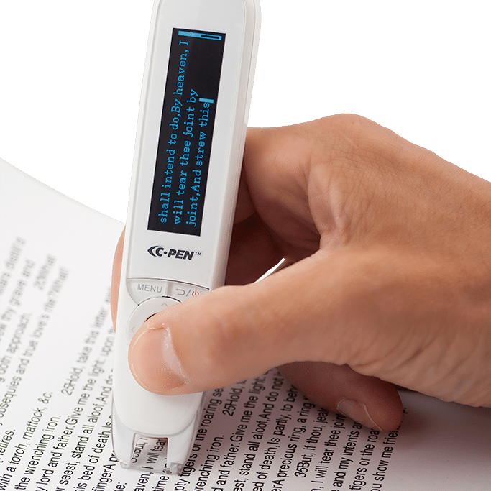
First, let’s think about what the challenges are. You know your child. ATI knows the gizmos and gadgets. Let’s combine expertise. Technology is not the answer for all challenges, but it can help many, so let the ATI tech specialists provide assistance, and come find out what is out there! We do show and tell really well! And remember that technology does not necessarily mean more computers – some tech is pretty simple.
C-Pen Reader
For kids with learning disabilities (actually learning differences!), reading and writing may take on special challenges. Words, letters, and numbers may jump around. By the time a kid gets to the end of a sentence, he or she may have forgotten what was at the first of the sentence, or be distracted by a period at the end of a sentence on the next page! No wonder some kids do not like to read. You can talk with your specialist at ATI about options, but here are some starter ideas. Try audio books so the kid can hear the story as well as see it -- more ways to understand. Try reading apps that guide the child through the sentence. Try smart pens that can translate right onto the computer screen. I think about the kid who drew his ideas – made more sense than the English teacher’s idea of outlining! And please, where were talking calculators when I was in school!?
Dolphin Smartpen
For kids with hearing loss, personal FM systems may help. They focus the sound and help kids catch what the teacher is saying. They also help reduce other noise that interferes. This system is also handy for kids with attention issues, because it screens out distracting noise. Are you listening to me, Charlie? Another wonderful gadget is a clipboard with a hearing loop built in. No one needs to know the kid needs a bit of extra help, he just looks very official and smart with his clipboard!
Kids with low vision may appreciate the audio books too. And magnifiers. And computer programs that magnify text.
There are lots of speech communication devices around too. There are programs that do speech to text and text to speech. Text to speech means the program scans the reading material and then reads it out in a synthesized voice. Speech to text means that the child talks and the program translates into written text. There are iPads with pictures and words that get triggered when a button is pushed.
There are so many options available, so the trick is to get the right one -- the one that works for your child. One size does not fit all. So work with the AT Specialist to find out what is here. Take a gadget home to try it out -- what works for Charlie may not work for Charlene. And what works for Charlie when he is three may not work for him when he is ten. Try several. Talk with your speech therapist or OT or PT.
Parents all want their kids to do well. And when kids have special challenges, it is admittedly harder. But know that you are not alone. Know there is help out there. (Tech Specialists have been invited to IEP (Individualized Education Plan) meetings to help explain how assistive technology can be useful.) We are here to serve. And we have a lot of stuff to show that could be just exactly the right stuff for your student.
Schedule time to meet with one of our Specialists. They are just a phone call 503-361-1201, or a click info@accesstechnologiesinc.org away.

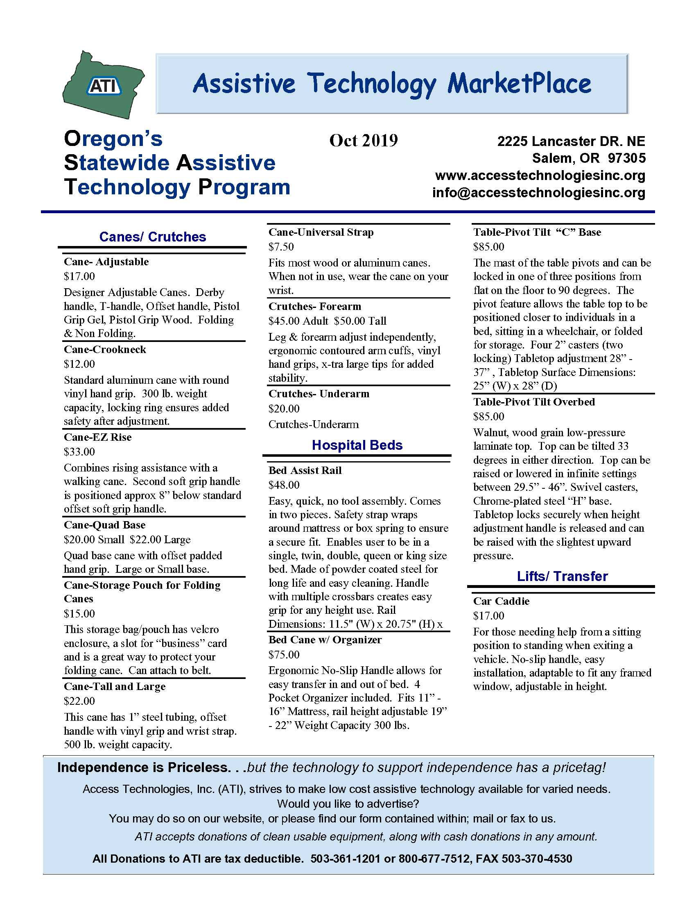
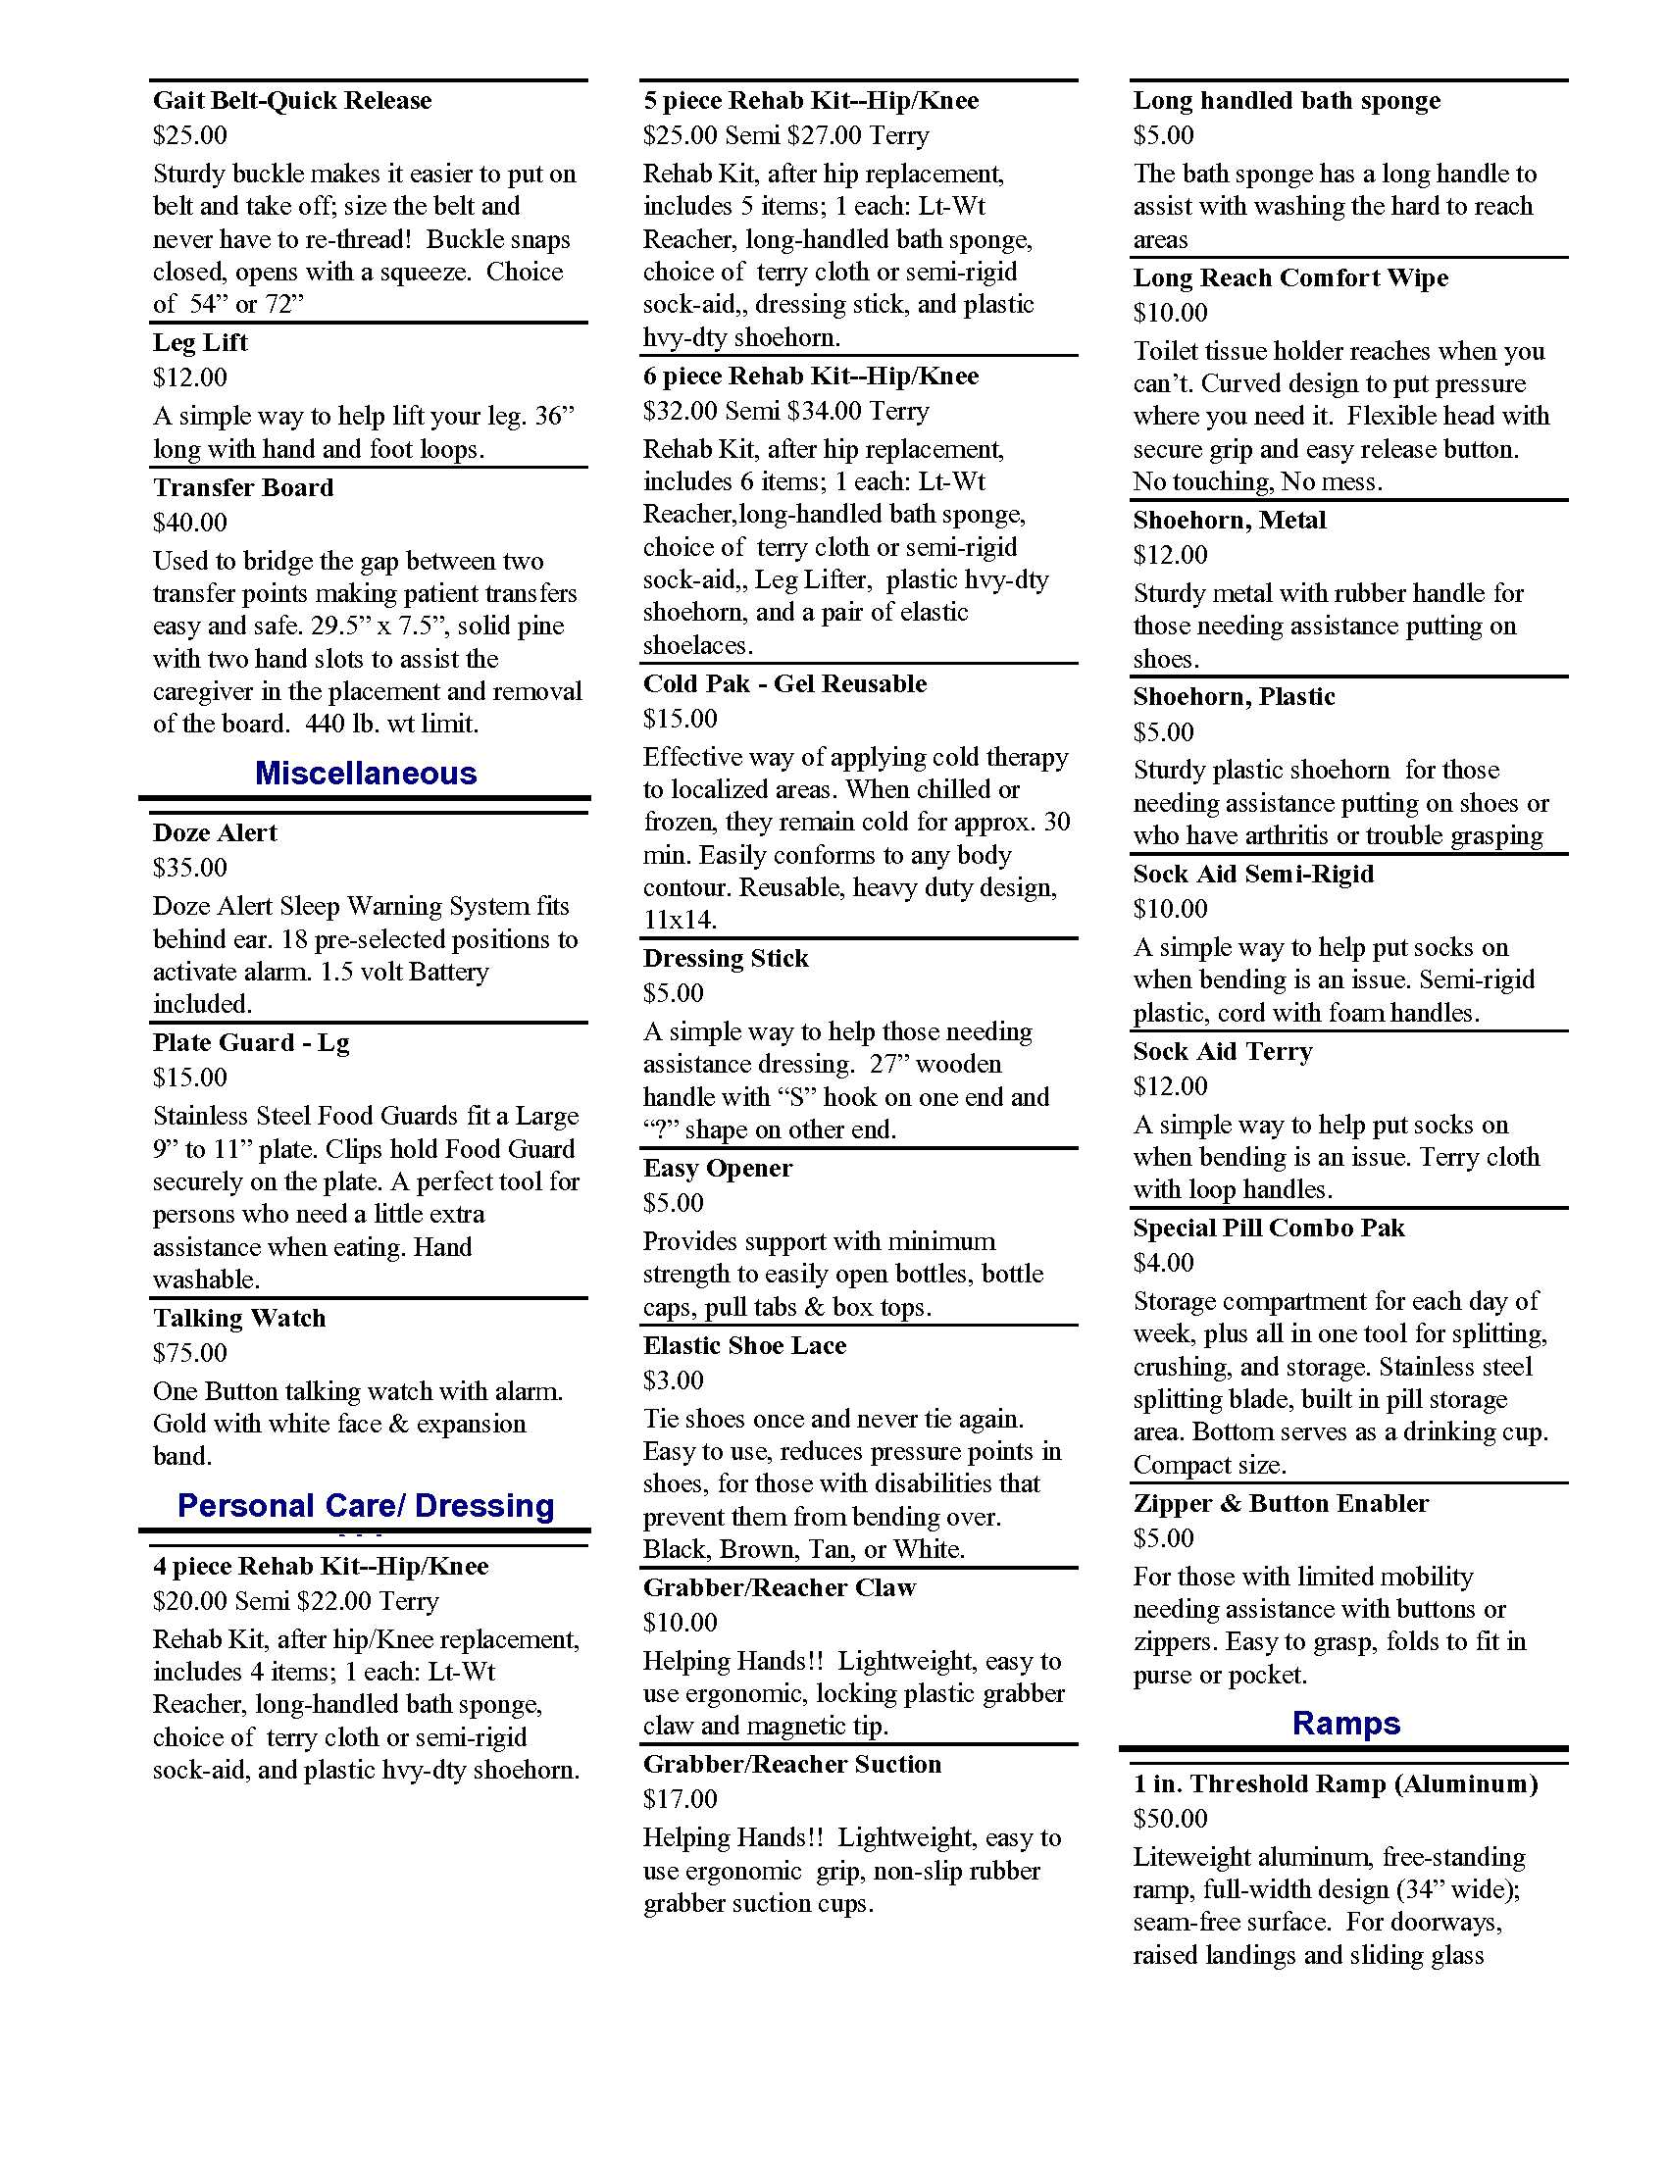
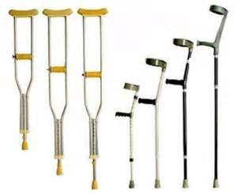
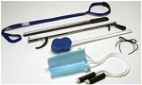
Button/Zipper Pull
Leg Lifter
MarketPlace
Page
Crutches
Six Piece Rehab Kit

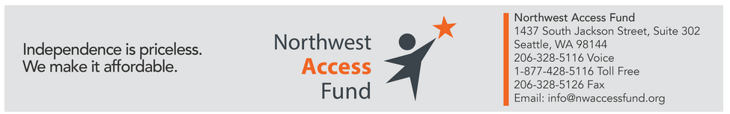
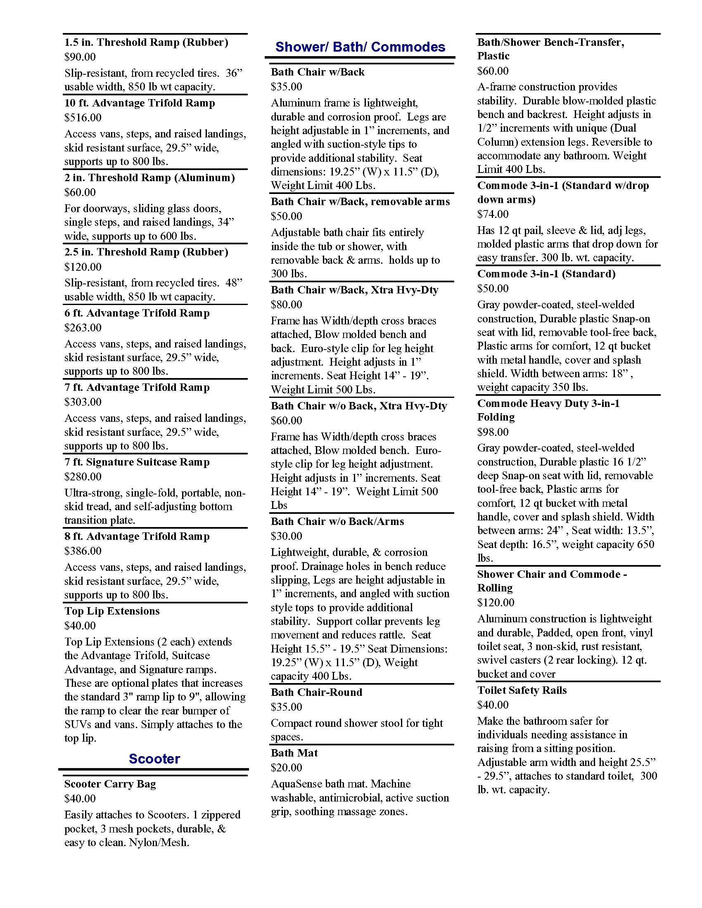

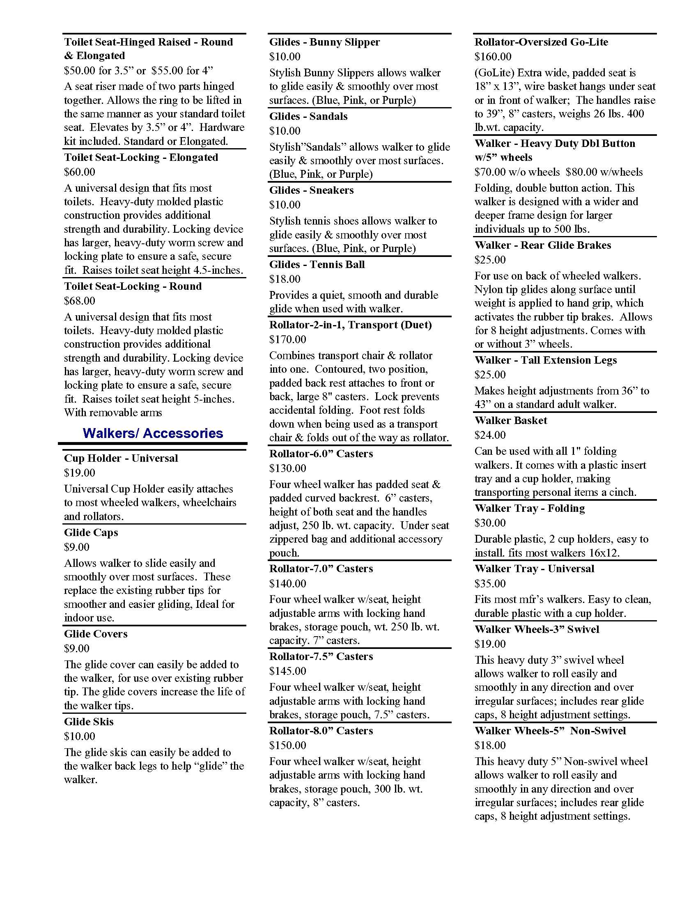

Glides
Bunny Slippers

Glide Skis

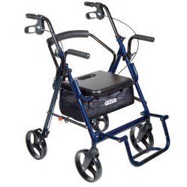
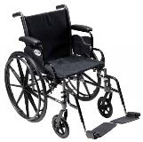
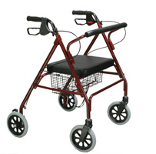
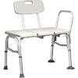
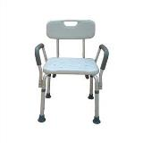
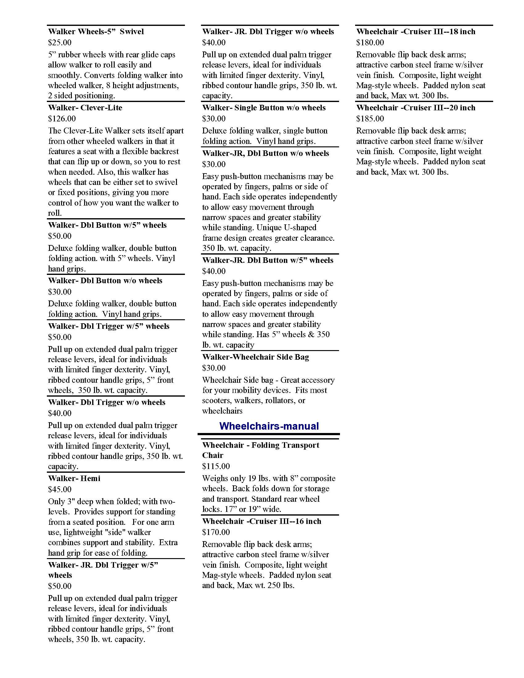
Toilet Safety Rails
Duet
Cruiser III Manual Wheelchair
GoLite Rollator
Bath Transfer Bench
Bath Chair
Transfer Board

