 | Tech It Easy | Access Technologies, Inc.  January 2020 Edition  Editor: Laurie Brooks

Inside this Issue:
You Are Not Alone | 1, 10-11
GrandPad | 2
ATM - MarketPlace | 3 – 8
Bargain Basement | 9
iCanConnect-Oregon | 12

You Are Not Alone

Being a parent is the coolest and hardest job anyone can have. And being the parent of a child with challenges, makes that job even harder. When you are coming to grips with what is going on with your child (Is this normal? Do other kids do this? What do I do about it? Is it just me?), you may feel quite alone.
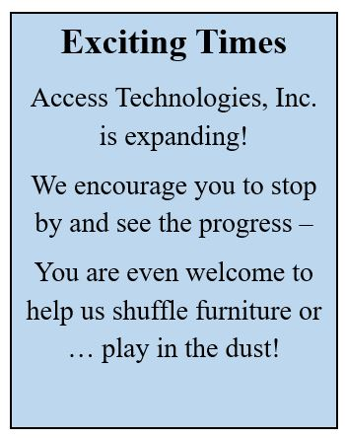
Even after getting a diagnosis, you may have questions that a physician or other professional may not be able to answer. That’s where parent support groups come to the rescue. Talking with other parents going through the same thing helps.
A support group can help fill in some of the gaps. Just knowing someone else is going through some of the same things that you are can be reassuring. It can help you feel more grounded and secure in your journey.
Parent support groups help you feel less alone. You find out that there are other kids out there like yours. These parents deal with the same (mostly) well-meaning, but ignorant comments: “But she looks fine!” or “You must be a saint.” In a support group, you find folks who understand and do not offer stupid platitudes.
Parent support groups can help you locate resources. Maybe you have a great speech therapist but need an occupational therapist. Someone is bound to have a name. Maybe you have not thought about using assistive technology, but someone else suggests a gadget. (Go to ATI to find the right one for you and how to use it!). Maybe someone else, dealing with the same behavior in her kid as you are, has a great strategy that works with her family. Try it out!
(Continued on page 10 – Not Alone)

Introducing the GrandPad!

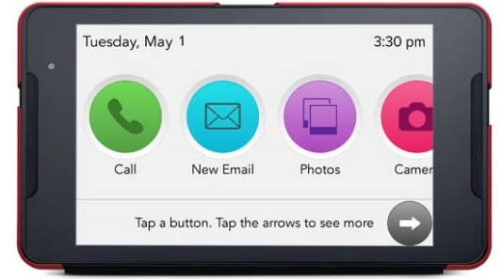
New to our Demonstration Center, the GrandPad is designed to allow your parents, grandparents, or other loved ones to have the ability to connect to family and friends with ease. The customized tablet allows users to send messages, browse the Internet, make video calls, stream music, and play games. For added security, a Family Administrator can manage security settings, contacts, and content for the GrandPad user.
The GrandPad comes with a wireless charging cradle and smart case, a setup guide, and a handy stylus for navigation. A monthly subscription through Consumer Cellular provides the convenience of unlimited data use, unlimited video calling, unlimited ad-free music streaming, customizable content, Internet browsing, as well as remote access for caregivers.

Key Benefits:
A chosen Family Administrator can use the web portal to invite family and friends and add personalized content to the device to ensure the GrandPad user remains engaged and secure.
Family and friends can use the free mobile companion app to upload photos and messages or video chat with the GrandPad user.
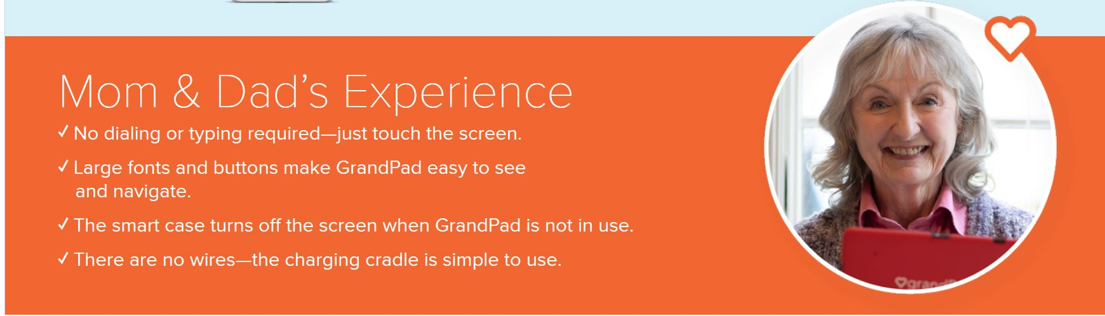
For more information, or to see a demonstration of the GrandPad, contact an ATI Specialist at 503-361-1201, or visit GrandPads online (www.grandpad.net). Let them know you learned about the GrandPad through your local Statewide Assistive Technology Program and save money on your purchase.

Assistive Technology MarketPlace

Oregon’s  Statewide Assistive Technology Program | January 2020 | 2225 Lancaster Dr. NE  Salem, OR 97305  www.accesstechnologiesinc.org  info@accesstechnologiesinc.org

Canes / Crutches
Cane – Adjustable  Designer Adjustable Canes. Derby handle, T-handle, Offset handle, Pistol Grip Gel, Pistol Grip Wood. Folding & Non-Folding. $17 | Cane – Crookneck  Standard aluminum cane with round vinyl hand grip, locking ring ensures added safety after adjustment. Weight capacity 300 lbs. $12 | Cane – EZ Rise  Combines rising assistance with a walking cane. Second soft grip handle is positioned approx. 8-inches below offset grip handle. $33
Cane – Quad Base  Quad base cane with offset padded hand-grip. Large or Small base style.  Small Base: $20  Large Base: $22 | Cane – Tall and Large  Cane has 1-inch steel tubing, offset handle with vinyl grip and wrist strap. Weight capacity 500 lbs. $22 | Crutches – Forearm or Underarm  Leg & forearm adjust independently, ergonomic contoured arm cuffs, vinyl hand grips, extra-large tips for added stability.  Adult Forearm: $45  Tall Forearm: $50  Underarm Style: $20

Hospital Beds
Bed Assist Rail  Easy, quick, no tool assembly. Comes in two pieces. Safety strap wraps around mattress or box spring to ensure a secure fit. Fits single, twin, double, queen or king size bed. Handle with multiple crossbars creates easy grip for multiple height use. Rail Dimensions: 11.5-inches (W) x 20.75-inches (H) x 21.5-inches (D). Weight Capacity 250 lbs.$48 | Table – Pivot Tilt C Base  The mast of the table pivots and can be locked in one of three positions from flat on the floor to 90 degrees. Pivot feature allows table top to be positioned closer to individuals in a bed, sitting in a wheelchair, or folded for storage. Four 2-inch casters (two locking) Tabletop adjustment 28-37 inches. Tabletop Surface Dimensions: 25-inches (W) x 28-inches (D) $85 | 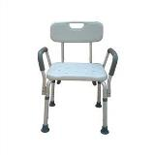  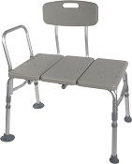  Bath Chair w/ Back and Arms  Bath Transfer Bench

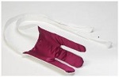
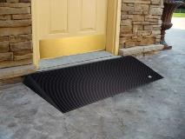
Terry Sock Aid
Walker Glides
Rubber Threshold Ramp

Lifts and Transfer
Transfer Board  Bridge gap between two transfer points making patient transfers easy and safe. 29.5-in. x 7.5-in., solid pine with two hand slots to assist the caregiver in the placement and removal of the board. Weight limit 440 lb. $40 | Car Caddie  For those needing help from a sitting position to standing when exiting a vehicle. No-slip handle, easy installation, adaptable to fit most framed windows, adjustable in height. $17 | Gait Belt – Quick Release  Sturdy buckle makes it easier to put on belt and take off. Size the belt and never have to re-thread! Buckle snaps closed, opens with a squeeze. Choice of 54 or 72 inch. $25
Leg Lift  A simple way to help lift your leg. 36-inches long with hand and foot loops. $12 | 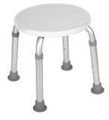  Round Bath Stool | 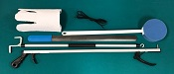  Six Piece Rehab Kit

Personal Care / Dressing
4 Piece Rehab Kit  Kit includes 1 of each:  Light weight Reacher, long-handled bath sponge, choice of terry cloth or semi-rigid sock-aid, and plastic heavy duty shoehorn.  Kit w/ Semi rigid sock aid $20  Kit w/ Terry sock aid $22 | 5 Piece Rehab Kit  Kit includes 1 of each:  Light weight Reacher, long-handled bath sponge, choice of terry cloth or semi-rigid sock-aid, dressing stick, and plastic heavy duty shoehorn.  Kit w/ Semi rigid sock aid $25  Kit w/ Terry sock aid $27 | 6 Piece Rehab Kit  Kit includes 1 of each:  Light weight Reacher, long-handled bath sponge, choice of terry cloth or semi-rigid sock-aid, leg lifter, plastic heavy duty shoehorn, and a pair of elastic shoelaces.  Kit w/ Semi rigid sock aid $32  Kit w/ Terry sock aid $34
Cold Pak – Gel Reusable  Apply cold therapy to localized areas. Remains cold for approximately 30 min. Easily conforms to body contour. Reusable, heavy duty design, 11x14. $15 | Grabber / Reacher  Lightweight, Locking plastic grabber claw with magnetic tip or non-slip rubber grabber suction cups.  Claw style $10  Suction style $17 | Elastic Shoe Lace  Tie shoes once and never tie again. Reduces pressure points in shoes, Black, Brown, Tan, or White, $3 per pair.
Dressing Stick  A simple way to help those needing assistance dressing. 27-inch wooden handle with “S” hook on one end and “?” shape on other end. $5 | Easy Opener  Provides support with minimum strength to easily open bottles, bottle caps, pull tabs & box tops. $5 | Long Handled Bath Sponge  The bath sponge has a long handle to assist with washing the hard to reach areas. $5
Long Reach Comfort Wipe  Toilet tissue holder reaches where you can’t. Curved design to put pressure where you need it. Flexible head with secure grip and easy release button. No touching, No mess. $10 | Shoehorn Metal or Plastic  Sturdy metal with rubber handle or Sturdy plastic for those needing assistance putting on shoes or who have arthritis or trouble grasping.  Metal style $12  Plastic style $5 | Sock aid Semi Rigid or Terry  A simple way to help put socks on when bending is an issue. Semi-rigid plastic, cord with foam handles. Or Terry Cloth with loop handles.  Semi Rigid style $10  Terry Cloth style $12

Ramps
Threshold Ramp - Aluminum  Liteweight, free standing ramp, full-width design 34 inches wide seam-free surface. For doorways, raised landings, single steps, and sliding glass. Weight capacity 600 lbs.  1-inch (H) $50  2-inch (H) $60 | Threshold Ramp Rubber.  Slip-resistant, from recycled tires. Weight capacity 850 lbs.  1.5-inch (H) x 36-in. (W) $90  2.5-inch (H) x 48-in. (W) $120 | 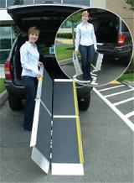  Advantage Trifold Ramp
Advantage Trifold Ramps.  Access vans, steps, and raised landings. Skid resistant surface, 29.5-inches wide, supports up to 800 lbs.  6-foot length: $263  7-foot length $303  8-foot length $386  10-foot length $516 | Signature Suitcase Ramp  6 Foot  Ultra-strong, single-fold, portable, non-skid tread, and self-adjusting bottom transition plate. $249 | Top Lip Extensions  Extends the Advantage Trifold, Suitcase Advantage, and Signature ramps. These optional plates increase the standard 3-inch ramp lip to 9, allowing the ramp to clear the rear bumper of SUVs and vans. Attaches to the top lip. $40 (per pair)

Shower / Bath
Bath Chair  without Back or Arms  Lightweight, durable, and corrosion proof. Legs are height adjustable in 1-inch increments, and angled with suction style tips; providing additional stability. Seat Height 15.5 - 19.5 inches. Seat Dimensions: 19.25-inches (W) x 11.5-inches (D), Weight capacity 400 lbs. $30 | Bath Chair with Back  without Arms  Aluminum frame is lightweight, durable and corrosion proof. Legs are height adjustable in 1-inch increments, and angled with suction-style tips to provide additional stability. Seat dimensions: 19.25-inches (W) x 11.5-inches (D), Weight Limit 400 lbs. $35 | Bath Chair Heavy Duty  with or without Back  Frame has width/depth cross braces attached, Blow molded bench. Euro-style clip for leg height adjustment. Height adjusts in 1-inch increments. Seat Height 14 - 19 inches. Weight Limit 500 lbs.  Without back $60  With back $80
Bath Mat  Adds safety by providing a large slip proof surface. Held securely by multiple suction cups. Mold resistant, latex free rubber. Size 15.75-in. x 35.5-in.  $20 | Bath/Shower Transfer Bench  A-frame construction provides stability. Durable blow-molded plastic bench and backrest. Height adjusts in ½ inch increments with unique (Dual Column) extension legs. Weight Limit 400 lbs. $60 | 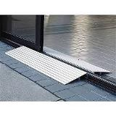  Threshold Ramp
Bath Chair Round  Compact round shower stool for tight spaces. $35 | 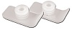  Walker Glide Skis | 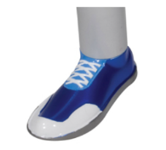  Walker Glides

Shower / Bath
Commode Standard 3 in 1  Gray powder-coated, steel-welded construction. Durable plastic Snap-on seat with lid, removable tool-free back. Plastic arms for comfort, 12-quart bucket with metal handle, cover and splash shield. Width between arms is 18 inches. Weight capacity 350 lbs. $50 | Commode Standard 3 in 1 With Drop Down Arms  Has 12-quart pail, sleeve & lid, adjustable legs, molded plastic arms that drop down for easy transfer. Weight capacity 300 lbs. $74 | Commode Heavy Duty 3 in 1 Folding  Gray powder-coated, steel-welded construction, Durable plastic 16 ½ inches deep. Snap-on seat with lid, removable tool-free back, plastic arms for comfort, 12-quart bucket with metal handle, cover and splash shield. Width between arms is 24 inches. Seat width: 13.5 inches, Seat depth: 16.5 inches. Weight capacity 650 lbs. $98
Rolling Shower Chair / Commode  Lightweight and durable, padded, open front, vinyl toilet seat, 4 non-skid, rust resistant, swivel casters (2 rear locking). 12-quart. bucket and cover. Weight capacity 300 lbs. $120 | Toilet Safety Rails  Make the bathroom safer for individuals needing assistance in raising from a seated position. Adjustable arm width and height 25.5 - 29.5 inches, attaches to standard toilet. Weight capacity 300 lbs. $40 | Raised Toilet Seat  Hinged  Two piece, hinged seat riser. Allows the ring to be lifted for cleaning. Elevates by 3.5 or 4 inches. Hardware kit included.  Standard or Elongated Styles.  3.5-inch rise: $50  4-inch rise: $55
Raised Toilet Seat Locking Round with removable arms  A universal design that fits most toilets. Heavy-duty molded plastic construction provides additional strength and durability. Locking device has larger, heavy-duty worm screw and locking plate to ensure a safe, secure fit. Raises toilet seat height 5 inches. $68 | 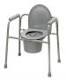  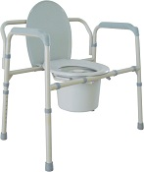  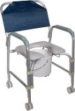  Commodes | 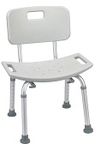  Bath Chair with Back

Walker / Accessories
Cup Holder – Universal  Universal Cup Holder easily attaches to most wheeled walkers, wheelchairs and rollators. $19 (pair) | Glide Caps  Allows walker to slide smoothly over most surfaces. These replace existing rubber tips for smoother and easier gliding, Ideal for indoor use. $9 (pair) | Glide Covers  The glide cover can easily be added to the walker, for use over existing rubber tip. The glide covers increase the life of the walker tips. $9 (pair)
Glide Skis  The glide skis can easily be added to the walker back legs to help “glide” the walker.  $10 (pair) | Glides – Bunny Slippers  Stylish Slippers allow walker to glide easily & smoothly over most surfaces. (Colors: Blue, Pink, or Purple) $10 (pair) | Glides – Sandals  Stylish Sandals allow walker to glide easily & smoothly over most surfaces. (Colors: Blue, Pink, or Purple) $10 (pair)

Walker / Accessories

Glides – Sneakers  Stylish tennis shoes allow walker to glide easily & smoothly over most surfaces. (Blue, Pink, or Purple) $10 (pair) | Glides – Tennis Ball  Provides a quiet, smooth and durable glide when used with walker. $18 (pair) | Walker Basket  Used with most 1 inch folding walkers. Includes plastic insert tray and a cup holder; makes transporting personal items a cinch. $24
Walker Tray Universal  Fits most manufactured walkers. Easy to clean, durable plastic with a cup holder. $35 | Walker Rear Glide Brakes  For use on back of wheeled walkers. Nylon tip glides along surface until weight is applied to hand grip, which activates the rubber tip brakes. Allows for 8 height adjustments. Comes with or without 3inch wheels.  $25 (pair) | Walker Tall Extension Legs  Makes height adjustments from 36 to 43 inches on a standard adult walker. $25 (pair)
Walker Wheels 3-inch Swivel  These heavy duty swivel wheels allow walker to roll easily and smoothly in any direction and over irregular surfaces; includes rear glide caps. 8 height adjustment settings. $19 (pair) | Walker Wheels 5-inch  Non Swivel  These heavy duty non-swivel wheels allow walker to roll easily and smoothly in any direction and over irregular surfaces; includes rear glide caps, 8 height adjustment settings. $18 (pair) | Walker Wheels 5-inch Swivel  Rubber wheels with rear glide caps allow walker to roll easily and smoothly. Converts folding walker into wheeled walker, 8 height adjustments. 2 sided positioning. $25 (pair)
Walker Adult Double Button With or Without Wheels  Deluxe folding walker, double button folding action. Vinyl hand grips.  Walker without wheels: $30  Walker with 5-inch wheels: $50 | Walker Adult Double Trigger With or Without Wheels  Pull up on extended dual palm trigger release levers, ideal for individuals with limited finger dexterity. Vinyl, ribbed contour handle grips, Weight capacity 350 lb.  Walker without wheels: $40  Walker with 5-inch wheels: $50 | Walker Adult Heavy Duty Double Button With or Without Wheels  Folding, double button action. This walker is designed with a wider and deeper frame design for larger individuals up to 500 lbs.  Walker without wheels: $50  Walker with 5-inch wheels: $70
Walker Junior Double Button With or Without Wheels  Deluxe folding walker, double button folding action. Vinyl hand grips. Weight capacity 350 lb.  Walker without wheels: $30  Walker with 5-inch wheels: $40 | Walker Junior Double Trigger With or Without Wheels  Pull up on extended dual palm trigger release levers, ideal for individuals with limited finger dexterity. Vinyl, ribbed contour handle grips, 350 lb. weight. capacity.  Walker without wheels: $40  Walker with 5-inch wheels: $50 | 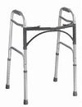  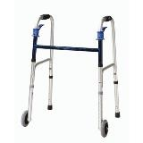  Double Button Walker  Double Trigger Walker

Walker / Accessories
Walker – Hemi  Only 3 inches deep when folded with two-levels. Provides support for standing from a seated position. For one arm use, lightweight side walker combines support and stability. Extra hand grip for ease of folding. $45 | Walker Clever Lite  The Clever-Lite Walker sets itself apart from other wheeled walkers in that it features a seat with a flexible backrest that can flip up or down, so you to rest when needed. Also, this walker has wheels that can be either set to swivel or fixed positions, giving you more control of how you want to roll. $126 | Rollator 2 in 1 – Duet  Combines transport chair & rollator into one. Contoured, two position, padded back rest attaches to front or back, large 8-inch casters. Lock prevents accidental folding. Foot rest folds down when being used as a transport chair & folds out of the way as rollator. $170
Rollator 6-inch Casters  Four-wheel walker w/seat, height adjustable arms with locking hand brakes, storage pouch. 250 lb. weight capacity. $130 | Rollator 7-inch Casters  Four-wheel walker w/seat, height adjustable arms with locking hand brakes, storage pouch, Weight capacity 250 lb.  $140 | Rollator 7.5- inch Casters  Four-wheel walker w/seat, height adjustable arms with locking hand brakes, storage pouch. $145
Rollator Oversized Go Lite  Extra wide, padded seat is 18 x 13 inches, wire basket hangs under seat or in front of walker; The handles raise to 39inches, has 8-inch casters, weighs 26 lbs. 400 lb. weight capacity. $160 | 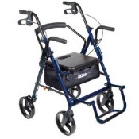  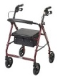  Duet  Rollator | 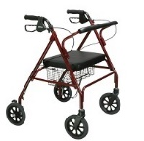  Go Lite Rollator

Wheelchair - Manual
Folding Transport Chair  17-Inch  Weighs only 19 lbs. with 8-inch composite wheels. Back folds down for storage and transport. Standard rear wheel locks.  $115 | Folding Transport Chair  19-Inch  Weighs only 19 lbs. with 8-inch composite wheels. Back folds down for storage and transport. Standard rear wheel locks.  $115 | 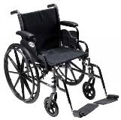  Cruiser III Manual Wheelchair
Wheelchair: Cruiser III  16-Inch  Removable flip back desk arms; carbon steel frame w/silver vein finish. Lightweight Mag-style wheels. Padded nylon seat and back. Your choice of elevating or swingaway legs.  Max weight: 250 pounds. $170 | Wheelchair: Cruiser III  18-Inch  Removable flip back desk arms; carbon steel frame w/silver vein finish. Light weight Mag-style wheels. Padded nylon seat and back. Your choice of elevating or swingaway legs.  Max weight: 300 lbs. $180 | Wheelchair: Cruiser III  20-Inch  Removable flip back desk arms; carbon steel frame w/silver vein finish. Light weight Mag-style wheels. Padded nylon seat and back. Your choice of elevating or swingaway legs.  Max weight: 300 lbs. $185

BARGAIN BASEMENT
Gently used equipment available at ATI in Salem
Canes / Crutches  Adjustable Cane U6500  $5 | Exercise Equipment  Wonder Core U6389  Tone your abs and strengthen your core in no time. Zeros in on your upper middle, lower abs and obliques. Adjustable resistance to build and tone muscles. $40 | Hearing  In-Line Phone Amplifier U569LL  Walker W10 is universally compatible and designed to increase incoming signals with up to 26 decibels of gain above the normal level. Works with most standard or electronic phone, single or multi-line $5
Bed Accessory  Bed Rail U6461  Invacare 6630 Half Length Bed Rail. 32-inches heavy duty steel, dual flat channel crossbraces secure with wing nut clamps. Adjustable height 4.75 to 15 inches. $50 | Health  Blood Pressure Cuff U6521  Automatic Blood Pressure Monitor $20  Chair Sensor Pad U6522  Sensor pad $20 | Mobility  Quantum Q6 Edge Power Chair U6525  Mid wheel 6 drive design, 16 x 22 foam cushion, swingaway joystick mount, flip up foot plate, ATX Suspension, 20 inch turning radius. $75
Pediatric  Standing Frame U6346  Pneumatic, 4 locking wheels, adjustable support pads, headrest, knee, foot, heel, and toe straps. Maximum weight 150 lbs. FREE | Ramps  Threshold Ramp 2-inch Aluminum U6419  For doorways, sliding glass door, single steps, and raised landings. 34 inches wide. Supports up to 600 lbs. $45 | Technology  Cordless Phone U6430  RadioShack brand amplified cordless phone. Amplified up to 35 decibels. Large backlit keypad, adjustable tone control. FREE
(Not Alone - continued from page 1)
Parent support groups give you a safe place to vent (If I have to do…one more time, I am gonna scream). You can talk about your real feelings. Nobody there claims sainthood nor will they expect you to have a halo. It is also a great place to share triumphs—some that only these folks will appreciate but are still really big!
And finally, parent support groups can help you maintain your sanity! All parents get tired (Can I just have 10 minutes to myself!?), confused (the doc says one thing and the therapist says something else), guilty (shouldn’t I be doing more?). Talking with others can help you recharge your batteries so you keep going. And laugh—at yourself, at the situation, at the dumb lady at the store who said what she did, at a silly joke that someone saw on Facebook. Laugh. And breathe, and celebrate. Support and be supported.
There are face-to-face support groups—aha, a time out of the house! And there are on-line groups. These are ideal for folks who may not have local support groups. They are great for times when travel might not be possible. They are great for times when you just need to vent—right now. They are great for times when you have a question (like in the middle of the night or right after a minor crisis, or trying to head off a crisis!). They are great for times you are doing ok and someone else has a question you can answer! They provide resources, links, and a way to connect with people you would never meet otherwise. And sometimes, it helps to be able to read something and have time to just think about how that fits your family; you do not need to respond right away. The more you know, the more choices you have. They are all good for making connections, gathering information, helping you understand, and most importantly, serving you as you serve your family.
Here are a few places to look for groups. And remember ATI is always here to serve. You are not alone! Provide your list of support groups to ATI and we will compile them on our website for others to quickly access.
Face-to Face Groups

CATO (Coalition for Assistive Technology of Oregon)
Resources for parents--help with IEP (Individualized Education Plan) meeting, identifying appropriate assistive technology Contact CATO at 541-445-2047.

FACT Oregon (formerly Family Action Coalition Team)
Peer-delivered support. Advocacy, education, mentoring. Phone 503-786-6082 or 1-888-988-3228 to contact FACT.

Oregon Family Support Network
Education, referral and advocacy. Staff are mainly parents or family members who have raised children with mental, behavioral, or other significant health issues. They also organize support groups. Call 503-363-8068 to contact Oregon Family Support Network.
And don’t forget about online resources too. Here are few to consider:
“For people without disabilities, technology
makes things easier.

For people with disabilities, technology
makes things possible.”
- Parent to Parent
Their motto is “ because I have been where you are”
Call 1-800-727-2706 or click Parent to Parent (www.parenttoparent.org)

- United Cerebral Palsy
In Oregon call 503-777-4166 or visit their website (www.ucpaorwa.org)

- Autism Speaks
Their motto is “ A Brighter Life on the Spectrum”
Go to AUTISM SPEAKS (www.autismspeaks.org) to learn more.

- Muscular Dystrophy Association
Peruse the MDA's website (www.mda.org) for more information.

- Spinal Muscular Atrophy
Did you know Spinal Muscular Atrophy is the leading genetic cause of death in infants? Go to Spinal Muscular Atrophy (www.curesma.org) for support and resources.

