 | Tech It Easy | Access Technologies, Inc.  June 2021 Edition  Editor: Laurie Brooks

Inside this Issue:
From Dream to Reality | 1-2, 10-11
ATM - MarketPlace | 3 – 8
Bargain Basement | 9
iCanConnect-Oregon | 12

From Dream to Reality
By Davey Hulse, Board Director

I never thought I would be the old gray-haired guy who would thrive on the “remember when” stories. But, remembering the dream, the steps that it took to bring that dream to reality, then peering off into the future with another dream in mind - that’s the beauty of this moment for me.
After almost 32 years being associated with what is now Access Technologies, Inc., I am retiring from the Board.
Opportunities Await
We still need dreamers and planners on both our Advisory Board, and
the Board of Directors. Are you that dreamer?

The dreams were something like this:
Imagine a place where a person with a disability, or friend or family of that person, could come to figure out what kinds of technology, techniques and tools might be available to adapt to limitations and get into the society’s mainstream. Imagine if that place had its very foundations in the wisdom of people with disabilities, their experiences, their creativity, their grasp of the complexities. And imagine that that knowledge could also come to the most remote doorstep in Oregon. Lastly, shopping for and trying gadgets would be done without regard to the brand of equipment. “Try this, now that one…now, the one back here.”
Oh, and did I mention that the dream included getting the costs of the right equipment down as low as possible?

A powerful and visionary group gathered those dreams and many more into the grant application to the federal government to do a demonstration project of how that dream would look in Oregon. Oregon got its first grant and was ready to start putting the nuts and bolts in place in 1990.
The tricky part was planning for some sort of change within five years. The federal money would start shrinking after a few years, so how would that look to Oregonians.
I think back to the first shopping lists of gadgets and gismos for the demonstration centers. The guides made sure that it included simple stuff like magnifiers, and that it included a full range up to and including the most complex computer systems of the time.
At year 5, the money started shrinking, and the State Legislature had no means for replacing those dollars.
A note of history. During that 5-year period, the Americans with Disabilities Act (ADA) was signed into law. Modifications were made to the Rehabilitation Act that spun off significant money into engineering and research for adaptive equipment and techniques. This thing called the Internet began to be more useful and available to ordinary people. Cell phones were changing from something the rich business person had in the car to something that would fit in a shirt pocket and was getting more affordable.
Join Our Team
ATI is growing and that means we are hiring! Check out our employment opportunities on our website at Join Our Team.
So, what would this now federally funded, state-wide consumer-controlled service system look like next?
The advisers envisioned a not-for-profit corporation who contracted with the State for the federal grant dollars, and also would set up systems to do fee-for-service evaluations and trainings, in hopes that one day it would be financially solid and not have to worry so much about whether federal funds would get renewed each year. (Continued on page 10 – Oregon AT Program)

Assistive Technology MarketPlace | Page 3

Oregon’s  Statewide Assistive Technology Program | June 2021 | 2225 Lancaster Dr. NE  Salem, OR 97305  www.accesstechnologiesinc.org  info@accesstechnologiesinc.org

Canes / Crutches
Cane – Adjustable  Designer Adjustable Canes. Derby handle, T-handle, Offset handle, Pistol Grip Gel, Pistol Grip Wood. Folding & Non-Folding. $17 | Cane – Crookneck  Standard aluminum cane with round vinyl hand grip, locking ring ensures added safety after adjustment. Weight capacity 300 lbs. $12 | Cane – EZ Rise  Combines rising assistance with a walking cane. Second soft grip handle is positioned approx. 8-inches below offset grip handle. $33
Cane – Quad Base  Quad base cane with offset padded hand-grip. Large or Small base style.  Small Base: $20  Large Base: $22 | Cane – Tall and Large  Cane has 1-inch steel tubing, offset handle with vinyl grip and wrist strap. Weight capacity 500 lbs. $22 | Crutches – Forearm or Underarm  Leg & forearm adjust independently, ergonomic contoured arm cuffs, vinyl hand grips, extra-large tips for added stability.  Adult Forearm: $45  Tall Forearm: $50  Underarm Style: $20

Hospital Beds
Bed Assist Rail  Easy, quick, no tool assembly. Comes in two pieces. Safety strap wraps around mattress or box spring to ensure a secure fit. Fits single, twin, double, queen or king size bed. Handle with multiple crossbars creates easy grip for multiple height use. Rail Dimensions: 11.5-inches (W) x 20.75-inches (H) x 21.5-inches (D). Weight Capacity 250 lbs. $48 | Table – Pivot Tilt C Base  The mast of the table pivots and can be locked in one of three positions from flat on the floor to 90 degrees. Pivot feature allows table top to be positioned closer to individuals in a bed, sitting in a wheelchair, or folded for storage. Four 2-inch casters (two locking) Tabletop adjustment 28-37 inches. Tabletop Surface Dimensions: 25-inches (W) x 28-inches (D). $85 | 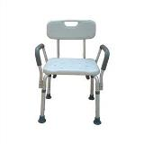  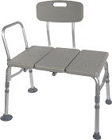  Bath Chair w/ Back and Arms  Bath Transfer Bench

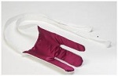
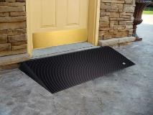
Terry Sock Aid
Walker Glides
Rubber Threshold Ramp

Lifts and Transfer
Transfer Board  Bridge gap between two transfer points making patient transfers easy and safe. 29.5-in. x 7.5-in., solid pine with two hand slots to assist the caregiver in the placement and removal of the board. Weight limit 440 lb. $40 | Car Caddie  For those needing help from a sitting position to standing when exiting a vehicle. No-slip handle, easy installation, adaptable to fit most framed windows, adjustable in height. $17 | Gait Belt – Quick Release  Sturdy buckle makes it easier to put on belt and take off. Size the belt and never have to re-thread! Buckle snaps closed, opens with a squeeze. Choice of 54 or 72 inch. $25
Leg Lift  A simple way to help lift your leg. 36-inches long with hand and foot loops. $12 | 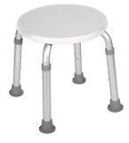  Round Bath Stool | 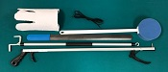  Six Piece Rehab Kit

Personal Care / Dressing
4 Piece Rehab Kit  Kit includes 1 of each:  Light weight Reacher, long-handled bath sponge, choice of terry cloth or semi-rigid sock-aid, and plastic heavy duty shoehorn.  Kit w/ Semi rigid sock aid $20  Kit w/ Terry sock aid $22 | 5 Piece Rehab Kit  Kit includes 1 of each:  Light weight Reacher, long-handled bath sponge, choice of terry cloth or semi-rigid sock-aid, dressing stick, and plastic heavy duty shoehorn.  Kit w/ Semi rigid sock aid $25  Kit w/ Terry sock aid $27 | 6 Piece Rehab Kit  Kit includes 1 of each:  Light weight Reacher, long-handled bath sponge, choice of terry cloth or semi-rigid sock-aid, leg lifter, plastic heavy duty shoehorn, and a pair of elastic shoelaces.  Kit w/ Semi rigid sock aid $32  Kit w/ Terry sock aid $34
Cold Pak – Gel Reusable  Apply cold therapy to localized areas. Remains cold for approximately 30 min. Easily conforms to body contour. Reusable, heavy duty design, 11x14. $15 | Grabber / Reacher  Lightweight, Locking plastic grabber claw with magnetic tip or non-slip rubber grabber suction cups.  Claw style $10  Suction style $17 | Elastic Shoe Lace  Tie shoes once and never tie again. Reduces pressure points in shoes, Black, Brown, Tan, or White, $3 per pair.
Dressing Stick  A simple way to help those needing assistance dressing. 27-inch wooden handle with “S” hook on one end and “?” shaped hook on the other end. $5 | Easy Opener  Provides support with minimum strength to easily open bottles, bottle caps, pull tabs and box tops. $5 | Long Handled Bath Sponge  The bath sponge has a long handle to assist with washing the hard to reach areas. $5
Long Reach Comfort Wipe  Toilet tissue holder reaches where you can’t. Curved design to put pressure where you need it. Flexible head with secure grip and easy release button. No touching, No mess. $10 | Shoehorn Metal or Plastic  Sturdy metal with rubber handle or Sturdy plastic for those needing assistance putting on shoes or who have arthritis or trouble grasping.  Metal style $12  Plastic style $5 | Sock aid Semi Rigid or Terry  A simple way to help put socks on when bending is an issue. Semi-rigid plastic, cord with foam handles. Or Terry Cloth with loop handles.  Semi Rigid style $10  Terry Cloth style $12

Ramps
Threshold Ramp - Aluminum  Lite weight, free standing ramp, full-width design 34 inches wide seam-free surface. For doorways, raised landings, single steps, and sliding glass. Weight capacity 600 lbs.  1-inch (H) $50  2-inch (H) $60 | Threshold Ramp Rubber.  Slip-resistant, from recycled tires. Weight capacity 850 lbs.  1.5-inch (H) x 36-in. (W) $90  2.5-inch (H) x 48-in. (W) $120 | 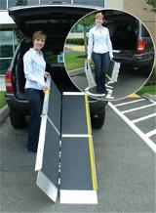  Advantage Trifold Ramp
Advantage Trifold Ramps.  Access vans, steps, and raised landings. Skid resistant surface, 29.5-inches wide, supports up to 800 lbs.  6-foot length: $263  7-foot length $303  8-foot length $386  10-foot length $516 | Signature Suitcase Ramp  6 Foot  Ultra-strong, single-fold, portable, non-skid tread, and self-adjusting bottom transition plate. $249 | Top Lip Extensions  Extends the Advantage Trifold, Suitcase Advantage, and Signature ramps. These optional plates increase the standard 3-inch ramp lip to 9, allowing the ramp to clear the rear bumper of SUVs and vans. Attaches to the top lip. $40 (per pair)

Shower / Bath
Bath Chair  without Back or Arms  Lightweight, durable, and corrosion proof. Legs are height adjustable in 1-inch increments, and angled with suction style tips; providing additional stability. Seat Height 15.5 - 19.5 inches. Seat Dimensions: 19.25-inches (W) x 11.5-inches (D). Weight capacity 400 lbs. $30 | Bath Chair with Back  with or without Arms  Aluminum frame is lightweight, durable and corrosion proof. Legs are height adjustable in 1-inch increments and angled with suction-style tips to provide additional stability.  Seat dimensions: 19.25-in (W) x 11.5-in. (D). Weight Limit 400 lbs. With Arms $50  Without Arms $35 | Bath Chair Heavy Duty  with or without Back  Frame has width/depth cross braces attached, Blow molded bench. Euro-style clip for leg height adjustment. Height adjusts in 1-inch increments. Seat Height 14 - 19 inches. Weight Limit 500 lbs.  Without back $60  With back $80
Bath Mat  Adds safety by providing a large slip proof surface. Held securely by multiple suction cups. Mold resistant, latex free rubber. Size 15.75-in. x 35.5-in.  $20 | Bath/Shower Transfer Bench  A-frame construction provides stability. Durable blow-molded plastic bench and backrest. Height adjusts in ½ inch increments with unique (Dual Column) extension legs. Weight Limit 400 lbs. $60 | 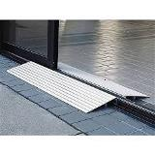  Threshold Ramp
Bath Chair Round  Compact round shower stool for tight spaces. $35 | 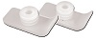  Walker Glide Skis | 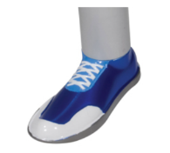  Walker Glides

Shower / Bath
Commode Standard 3 in 1  Gray powder-coated, steel-welded construction. Durable plastic Snap-on seat with lid, removable tool-free back. Plastic arms for comfort, 12-quart bucket with metal handle, cover and splash shield. Width between arms is 18 inches. Weight capacity 350 lbs. $50 | Commode Standard 3 in 1 With Drop Down Arms  Has 12-quart pail, sleeve & lid, adjustable legs, molded plastic arms that drop down for easy transfer. Weight capacity 300 lbs. $74 | Commode Heavy Duty 3 in 1 Folding  Gray powder-coated, steel-welded construction, Durable plastic 16 ½ inches deep. Snap-on seat with lid, removable tool-free back, plastic arms for comfort, 12-quart bucket with metal handle, cover and splash shield. Width between arms is 24 inches. Seat width: 13.5 inches, Seat depth: 16.5 inches. Weight capacity 650 lbs. $98
Rolling Shower Chair / Commode  Lightweight and durable, padded, open front, vinyl toilet seat, 4 non-skid, rust resistant, swivel casters (2 rear locking). 12-quart. bucket and cover. Weight capacity 300 lbs. $120 | Toilet Safety Rails  Make the bathroom safer for individuals needing assistance in raising from a seated position. Adjustable arm width and height 25.5 - 29.5 inches, attaches to standard toilet. Weight capacity 300 lbs. $40 | Raised Toilet Seat  Hinged  Two piece, hinged seat riser. Allows the ring to be lifted for cleaning. Elevates by 3.5 or 4 inches. Hardware kit included.  Standard or Elongated Styles.  3.5-inch rise: $50  4-inch rise: $55
Raised Toilet Seat Locking with removable arms  Round or Elongated style available. Heavy-duty molded plastic construction provides additional strength and durability. Locking device has larger, heavy-duty worm screw and locking plate to ensure a safe, secure fit. Raises toilet seat height 5 inches. $68 | 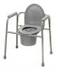  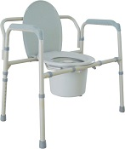  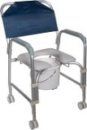  Commodes | 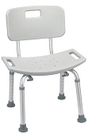  Bath Chair with Back

Walker / Accessories
Cup Holder – Universal  Universal Cup Holder easily attaches to most wheeled walkers, wheelchairs and rollators. $19 (pair) | Glide Caps  Allows walker to slide smoothly over most surfaces. These replace existing rubber tips for smoother and easier gliding, Ideal for indoor use. $9 (pair) | Glide Covers  The glide cover can easily be added to the walker, for use over existing rubber tip. The glide covers increase the life of the walker tips. $9 (pair)
Glide Skis  The glide skis can easily be added to the walker back legs to help “glide” the walker.  $10 (pair) | Glides – Bunny Slippers  Stylish Slippers allow walker to glide easily & smoothly over most surfaces. (Colors: Blue, Pink, or Purple) $10 (pair) | Glides – Sandals  Stylish Sandals allow walker to glide easily & smoothly over most surfaces. (Colors: Blue, Pink, or Purple) $10 (pair)

Walker / Accessories

Glides – Sneakers  Stylish tennis shoes allow walker to glide easily & smoothly over most surfaces. (Blue, Pink, or Purple) $10 (pair) | Glides – Tennis Ball  Provides a quiet, smooth and durable glide when used with walker. $18 (pair) | Walker Basket  Used with most 1 inch folding walkers. Includes plastic insert tray and a cup holder; makes transporting personal items a cinch. $24
Walker Tray Universal  Fits most manufactured walkers. Easy to clean, durable plastic with a cup holder. $35 | Walker Rear Glide Brakes  For use on back of wheeled walkers. Nylon tip glides along surface until weight is applied to hand grip, which activates the rubber tip brakes. Allows for 8 height adjustments. Comes with or without 3inch wheels.  $25 (pair) | Walker Tall Extension Legs  Makes height adjustments from 36 to 43 inches on a standard adult walker. $25 (pair)
Walker Wheels 3-inch Swivel  These heavy duty swivel wheels allow walker to roll easily and smoothly in any direction and over irregular surfaces; includes rear glide caps. 8 height adjustment settings. $19 (pair) | Walker Wheels 5-inch  Non Swivel  These heavy duty non-swivel wheels allow walker to roll easily and smoothly in any direction and over irregular surfaces; includes rear glide caps, 8 height adjustment settings. $18 (pair) | Walker Wheels 5-inch Swivel  Rubber wheels with rear glide caps allow walker to roll easily and smoothly. Converts folding walker into wheeled walker, 8 height adjustments. 2 sided positioning. $25 (pair)
Walker Adult Double Button With or Without Wheels  Deluxe folding walker, double button folding action. Vinyl hand grips.  Walker without wheels: $30  Walker with 5-inch wheels: $50 | Walker Adult Double Trigger With or Without Wheels  Pull up on extended dual palm trigger release levers, ideal for individuals with limited finger dexterity. Vinyl, ribbed contour handle grips, Weight capacity 350 lb.  Walker without wheels: $40  Walker with 5-inch wheels: $50 | Walker Adult Heavy Duty Double Button With or Without Wheels  Folding, double button action. This walker is designed with a wider and deeper frame design for larger individuals up to 500 lbs.  Walker without wheels: $50  Walker with 5-inch wheels: $70
Walker Junior Double Button With or Without Wheels  Deluxe folding walker, double button folding action. Vinyl hand grips. Weight capacity 350 lb.  Walker without wheels: $30  Walker with 5-inch wheels: $40 | Walker Junior Double Trigger With or Without Wheels  Pull up on extended dual palm trigger release levers, ideal for individuals with limited finger dexterity. Vinyl, ribbed contour handle grips, 350 lb. weight. capacity.  Walker without wheels: $40  Walker with 5-inch wheels: $50 | 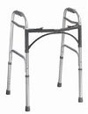  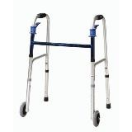  Double Button Walker  Double Trigger Walker

Walker / Accessories
Walker – Hemi  Only 3 inches deep when folded with two-levels. Provides support for standing from a seated position. For one arm use, lightweight side walker combines support and stability. Extra hand grip for ease of folding. $45 | Walker Clever Lite  The Clever-Lite Walker sets itself apart from other wheeled walkers in that it features a seat with a flexible backrest that can flip up or down, so you to rest when needed. Also, this walker has wheels that can be either set to swivel or fixed positions, giving you more control of how you want to roll. $126 | Rollator 2 in 1 – Duet  Combines transport chair & rollator into one. Contoured, two position, padded back rest attaches to front or back, large 8-inch casters. Lock prevents accidental folding. Footrest folds down when being used as a transport chair and folds out of the way as rollator. $170
Rollator 6-inch Casters  Four-wheel walker w/seat, height adjustable arms with locking hand brakes, storage pouch. 250 lb. weight capacity. $130 | Rollator 7-inch Casters  Four-wheel walker w/seat, height adjustable arms with locking hand brakes, storage pouch, Weight capacity 250 lb.  $140 | Rollator 7.5- inch Casters  Four-wheel walker w/seat, height adjustable arms with locking hand brakes, storage pouch. $145
Rollator Oversized Go Lite  Extra wide, padded seat is 18 x 13 inches, wire basket hangs under seat or in front of walker; The handles raise to 39inches, has 8-inch casters, weighs 26 lbs. 400 lb. weight capacity. $160 | 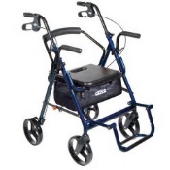  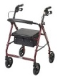  Duet  Rollator | 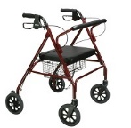  Go Lite Rollator

Wheelchair - Manual
Folding Transport Chair  17-Inch  Weighs only 19 lbs. with 8-inch composite wheels. Back folds down for storage and transport. Standard rear wheel locks.  $115 | Folding Transport Chair  19-Inch  Weighs only 19 lbs. with 8-inch composite wheels. Back folds down for storage and transport. Standard rear wheel locks.  $115 | 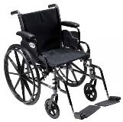  Cruiser III Manual Wheelchair
Wheelchair: Cruiser III  16-Inch  Removable flip back desk arms; carbon steel frame w/silver vein finish. Lightweight Mag-style wheels. Padded nylon seat and back. Your choice of elevating or swingaway legs.  Max weight: 250 pounds. $170 | Wheelchair: Cruiser III  18-Inch  Removable flip back desk arms; carbon steel frame w/silver vein finish. Light weight Mag-style wheels. Padded nylon seat and back. Your choice of elevating or swingaway legs.  Max weight: 300 lbs. $180 | Wheelchair: Cruiser III  20-Inch  Removable flip back desk arms; carbon steel frame w/silver vein finish. Light weight Mag-style wheels. Padded nylon seat and back. Your choice of elevating or swingaway legs.  Max weight: 300 lbs. $185

BARGAIN BASEMENT
Gently used equipment available at ATI in Salem
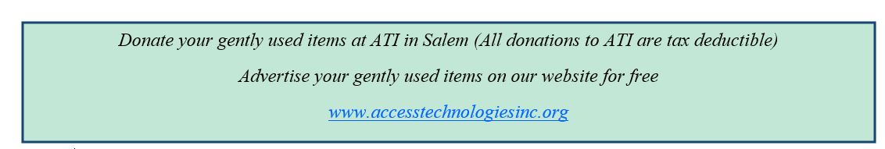
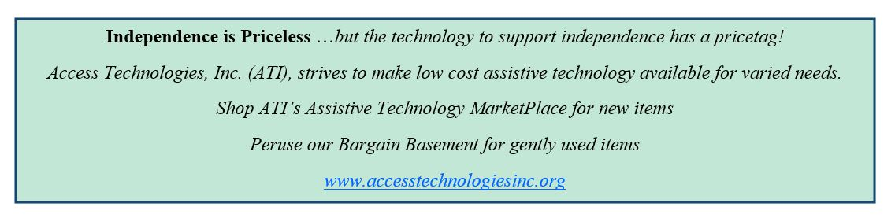
Vision  Economy Dome Magnifier U6566 $5  Economy Dome Magnifier  U6567 $5 | Wheelchair  Permobile C500 Electric Wheelchair / Stander  Elite power chair with extra bars and pads to keep person in standing position. with desk. $600 | Hearing  In-Line Phone Amplifier U569LL  Walker W10 is universally compatible and designed to increase incoming signals with up to 26 decibels of gain above the normal level. $5
Hospital Beds  Bed Rail U6561  Invacare Half Length Bed Rail. (Twin). $25 | Wheelchair  Permobile C500 Electric Wheelchair / Stander  Elite power chair with bars and pads to keep person in standing position. with desk.  Without Batteries $150  With Batteries $600 | Wheelchair  Pediatric Wheelchair U6574  Pediatric Invacare Orbit Tilt-in-Space with detachable seat frame. 55-degree tilt range, adj. pivot point, telescoping front riggings. Seat grows from 10”x10” to 16”x16”. Weight capacity 150 pounds. $20
Mobility  Hemi Walker  Provides support for standing from a seated position $15 | Technology FREE  XL-40 Amplified Phone U6527 | Technology FREE  Cordless Phone U6430  RadioShack brand amplified cordless phone. Amplified up to 35 decibels. Large backlit keypad, adjustable tone control.

(Oregon AT Program - continued from page 2)
A board of Directors was built with people from the advisory board.
We had the seeds, though, for that place that brought physical form to those dreams.
Time sped by. The actual physical locations changed. Gadgets and gismos that were only dreamed about in science fiction and shown on “Get Smart” (go find it on streaming), became reality, became more available and cheaper, and now are part of every-day life.
Many historical moments blessed Access Technologies, Inc., ATI. When President Obama and Congress pumped money into the economy, one way to get the money out to communities was through grants. It was mostly for one-time purchases…ah, more gadgets and gismos. Suddenly, the demonstration lab had all sorts of those sci fi gadgets. A long-time friend of mine who is paralyzed from the neck down had been an avid hunter. We got a set up that someone like him could use to aim a rifle using no hands. There were tiny walkers. There were up-to-date tablet computers…and more and more and more.
Always Planning for the Future

And now, COVID-19 thrust us headlong into using ways of communicating across our state in a face-to-face video call. Sci fi started the dream, geeks wrote the code, and now grandma can see the blessed faces of her grandchildren who live far away, or in the next town over where they can’t go. A year and a half ago, I didn’t know what a Zoom meeting was.
So, what will ATI look like in 5 years, or 10, or 30? What mind-blowing gadgets will have become commonplace? How will the experts in technology working at ATI deliver knowledge, equipment trials, and training? How will we assure that the yet unborn child who arrives with disabilities be assured of full participation in society?

I close with this: Those dreams I talked about when I started…well, they have come true.
- Our Advisory Board lives up to the consumer majority standard.
- Our Board of Directors is also consumer controlled.
- You can call or visit our center to talk about your “if I could just” list and find a resource.
- You and the friendly expert may decide you could use a loaner piece of equipment that seems just right. After you try it, you may decide you want to buy it yourself rather than fooling with an insurance company. We can order it. We can set it up and deliver it. We can train you on it.
And, if the Specialists don’t know of something that might be the right fit, they’ll go hunting. It is their job to continually learn about the newest and greatest, or the really inventive way to solve a particular problem.
Have You Dreamed About a Job:
- where you help people find solutions to physical, mental, sensory, and emotional challenges?
- that presents you with opportunities to learn and get paid to do it?
Today you may be cleaning up a donated wheelchair so that someone can buy it inexpensively. Later, you may be scrubbing the hard drives on donated computers. Then, you may be helping one of the technology specialists assemble a workstation and computer system for delivery. Or you may be watching as an elder with vision loss can use a gadget to see to thread a needle or read a crochet pattern.
We’re hiring individuals who have these dreams. Explore the position descriptions listed under “Join Our Team on our website at www.accesstechnologiesinc.org

