 | Tech It Easy | Access Technologies, Inc.  October 2020 Edition  Editor: Laurie Brooks

Inside this Issue:
In-Home Services During COVID-19 | 1, 10-11
The Unexpected | 2, 11
ATM - MarketPlace | 3 – 8
Bargain Basement | 9
iCanConnect-Oregon | 12

Hiring In-Home Services or Repairs

During the Time of COVID-19

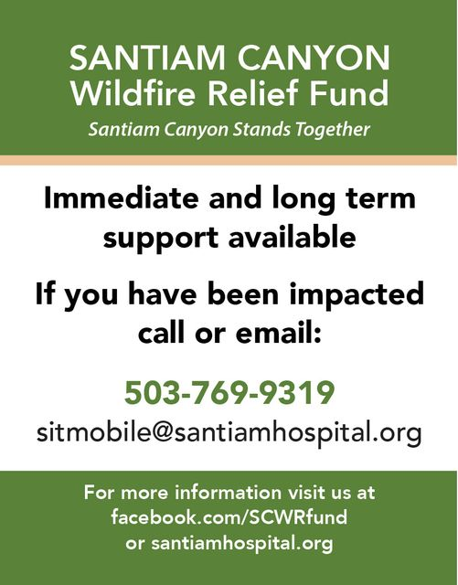
The Centers for Disease Control and Prevention (CDC), offers the following tips for staying safe and slowing the spread of COVID-19 while scheduling services or repairs inside your home. These services may include installation and repair of plumbing, electrical, heating, or air conditioning systems; painting; cleaning services; and even setup, installation, and training of your assistive technology devices with our Assistive Technology Specialists.
It is important to remember, that in general, the closer and longer you interact with others, the higher the risk of COVID-19 spreading. Therefore, limiting close face-to-face contact and staying at least 6 feet away from other people is the best way to reduce the risk of COVID-19 infection, along with wearing masks and practicing everyday preventive actions. Before welcoming service providers into your home, consider the following tips to help keep you, your family, and the service provider safe during your in-home services or repairs:

(Continued on page 10 – Before the Visit)

The Unexpected

The media and the medical community often promote the wonders of a healthy, active lifestyle at any age. And even though the “golden years” may bring some physical changes, most people—young and old—have come to expect they will live long, healthy and unencumbered lives. Consequently, when you or someone you love is faced with a disabling illness or injury, you are taken by surprise. Having to deal with a disability is not something most people anticipate.
When people realize that a disability, their own or a loved one’s, is going to be permanent, they may express a variety of reactions from shock to fear to grief to anger. There is no “right” way to respond. People generally react according to what the disability means to them and just how much it is going to affect or change their lives. Generally speaking, those who accept and make adjustments for their new lifestyle will have an easier time coping. If you’ve developed a disability, acknowledge your limitations, and as you concentrate on what you can do, turn to Access Technologies, Inc. for information on simple, easy to use devices that will allow you to accomplish even more. Here are few examples that may assist you.
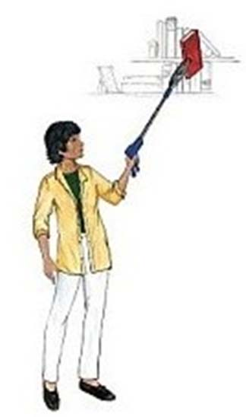
Reacher/grabbers are great accommodations if you have a bad back, have had knee or hip surgery and can’t bend, or if you have limited mobility, picking up things you’ve dropped can be a painful task. If you have a bad neck that hates tilting up and down, overreaching to get cans off that high shelf can be a real issue.
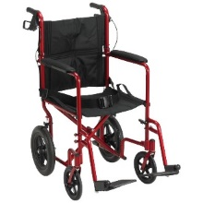
Magnification devices are available in a variety of sizes and magnification levels. Handheld magnifiers are designed for quick spot reading, like when you are trying to read the care label of your new blouse, adjust the thermostat, or read the menu at your favorite restaurant. While electronic vision aids are great for reading your favorite novel or completing a crossword puzzle.
Transport chairs are great when you experience difficulties walking through the store, into the doctor’s office, or just for a stroll in the neighborhood with a loved one. Look for a lightweight model, that folds easily for stowing in your vehicle.
(Accommodations continued on page 11)

Assistive Technology MarketPlace | Page 3

Oregon’s  Statewide Assistive Technology Program | October 2020 | 2225 Lancaster Dr. NE  Salem, OR 97305  www.accesstechnologiesinc.org  info@accesstechnologiesinc.org

Canes / Crutches
Cane – Adjustable  Designer Adjustable Canes. Derby handle, T-handle, Offset handle, Pistol Grip Gel, Pistol Grip Wood. Folding & Non-Folding. $17 | Cane – Crookneck  Standard aluminum cane with round vinyl hand grip, locking ring ensures added safety after adjustment. Weight capacity 300 lbs. $12 | Cane – EZ Rise  Combines rising assistance with a walking cane. Second soft grip handle is positioned approx. 8-inches below offset grip handle. $33
Cane – Quad Base  Quad base cane with offset padded hand-grip. Large or Small base style.  Small Base: $20  Large Base: $22 | Cane – Tall and Large  Cane has 1-inch steel tubing, offset handle with vinyl grip and wrist strap. Weight capacity 500 lbs. $22 | Crutches – Forearm or Underarm  Leg & forearm adjust independently, ergonomic contoured arm cuffs, vinyl hand grips, extra-large tips for added stability.  Adult Forearm: $45  Tall Forearm: $50  Underarm Style: $20

Hospital Beds
Bed Assist Rail  Easy, quick, no tool assembly. Comes in two pieces. Safety strap wraps around mattress or box spring to ensure a secure fit. Fits single, twin, double, queen or king size bed. Handle with multiple crossbars creates easy grip for multiple height use. Rail Dimensions: 11.5-inches (W) x 20.75-inches (H) x 21.5-inches (D). Weight Capacity 250 lbs. $48 | Table – Pivot Tilt C Base  The mast of the table pivots and can be locked in one of three positions from flat on the floor to 90 degrees. Pivot feature allows table top to be positioned closer to individuals in a bed, sitting in a wheelchair, or folded for storage. Four 2-inch casters (two locking) Tabletop adjustment 28-37 inches. Tabletop Surface Dimensions: 25-inches (W) x 28-inches (D). $85 | 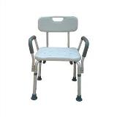  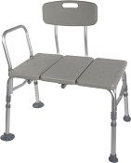  Bath Chair w/ Back and Arms  Bath Transfer Bench

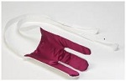
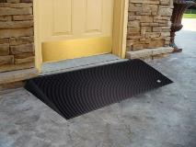
Terry Sock Aid
Walker Glides
Rubber Threshold Ramp

Lifts and Transfer
Transfer Board  Bridge gap between two transfer points making patient transfers easy and safe. 29.5-in. x 7.5-in., solid pine with two hand slots to assist the caregiver in the placement and removal of the board. Weight limit 440 lb. $40 | Car Caddie  For those needing help from a sitting position to standing when exiting a vehicle. No-slip handle, easy installation, adaptable to fit most framed windows, adjustable in height. $17 | Gait Belt – Quick Release  Sturdy buckle makes it easier to put on belt and take off. Size the belt and never have to re-thread! Buckle snaps closed, opens with a squeeze. Choice of 54 or 72 inch. $25
Leg Lift  A simple way to help lift your leg. 36-inches long with hand and foot loops. $12 | 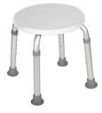  Round Bath Stool | 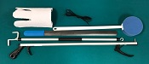  Six Piece Rehab Kit

Personal Care / Dressing
4 Piece Rehab Kit  Kit includes 1 of each:  Light weight Reacher, long-handled bath sponge, choice of terry cloth or semi-rigid sock-aid, and plastic heavy duty shoehorn.  Kit w/ Semi rigid sock aid $20  Kit w/ Terry sock aid $22 | 5 Piece Rehab Kit  Kit includes 1 of each:  Light weight Reacher, long-handled bath sponge, choice of terry cloth or semi-rigid sock-aid, dressing stick, and plastic heavy duty shoehorn.  Kit w/ Semi rigid sock aid $25  Kit w/ Terry sock aid $27 | 6 Piece Rehab Kit  Kit includes 1 of each:  Light weight Reacher, long-handled bath sponge, choice of terry cloth or semi-rigid sock-aid, leg lifter, plastic heavy duty shoehorn, and a pair of elastic shoelaces.  Kit w/ Semi rigid sock aid $32  Kit w/ Terry sock aid $34
Cold Pak – Gel Reusable  Apply cold therapy to localized areas. Remains cold for approximately 30 min. Easily conforms to body contour. Reusable, heavy duty design, 11x14. $15 | Grabber / Reacher  Lightweight, Locking plastic grabber claw with magnetic tip or non-slip rubber grabber suction cups.  Claw style $10  Suction style $17 | Elastic Shoe Lace  Tie shoes once and never tie again. Reduces pressure points in shoes, Black, Brown, Tan, or White, $3 per pair.
Dressing Stick  A simple way to help those needing assistance dressing. 27-inch wooden handle with “S” hook on one end and “?” shaped hook on the other end. $5 | Easy Opener  Provides support with minimum strength to easily open bottles, bottle caps, pull tabs and box tops. $5 | Long Handled Bath Sponge  The bath sponge has a long handle to assist with washing the hard to reach areas. $5
Long Reach Comfort Wipe  Toilet tissue holder reaches where you can’t. Curved design to put pressure where you need it. Flexible head with secure grip and easy release button. No touching, No mess. $10 | Shoehorn Metal or Plastic  Sturdy metal with rubber handle or Sturdy plastic for those needing assistance putting on shoes or who have arthritis or trouble grasping.  Metal style $12  Plastic style $5 | Sock aid Semi Rigid or Terry  A simple way to help put socks on when bending is an issue. Semi-rigid plastic, cord with foam handles. Or Terry Cloth with loop handles.  Semi Rigid style $10  Terry Cloth style $12

Ramps
Threshold Ramp - Aluminum  Lite weight, free standing ramp, full-width design 34 inches wide seam-free surface. For doorways, raised landings, single steps, and sliding glass. Weight capacity 600 lbs.  1-inch (H) $50  2-inch (H) $60 | Threshold Ramp Rubber.  Slip-resistant, from recycled tires. Weight capacity 850 lbs.  1.5-inch (H) x 36-in. (W) $90  2.5-inch (H) x 48-in. (W) $120 | 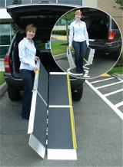  Advantage Trifold Ramp
Advantage Trifold Ramps.  Access vans, steps, and raised landings. Skid resistant surface, 29.5-inches wide, supports up to 800 lbs.  6-foot length: $263  7-foot length $303  8-foot length $386  10-foot length $516 | Signature Suitcase Ramp  6 Foot  Ultra-strong, single-fold, portable, non-skid tread, and self-adjusting bottom transition plate. $249 | Top Lip Extensions  Extends the Advantage Trifold, Suitcase Advantage, and Signature ramps. These optional plates increase the standard 3-inch ramp lip to 9, allowing the ramp to clear the rear bumper of SUVs and vans. Attaches to the top lip. $40 (per pair)

Shower / Bath
Bath Chair  without Back or Arms  Lightweight, durable, and corrosion proof. Legs are height adjustable in 1-inch increments, and angled with suction style tips; providing additional stability. Seat Height 15.5 - 19.5 inches. Seat Dimensions: 19.25-inches (W) x 11.5-inches (D). Weight capacity 400 lbs. $30 | Bath Chair with Back  without Arms  Aluminum frame is lightweight, durable and corrosion proof. Legs are height adjustable in 1-inch increments and angled with suction-style tips to provide additional stability.  Seat dimensions: 19.25-in (W) x 11.5-in. (D). Weight Limit 400 lbs. $35 | Bath Chair Heavy Duty  with or without Back  Frame has width/depth cross braces attached, Blow molded bench. Euro-style clip for leg height adjustment. Height adjusts in 1-inch increments. Seat Height 14 - 19 inches. Weight Limit 500 lbs.  Without back $60  With back $80
Bath Mat  Adds safety by providing a large slip proof surface. Held securely by multiple suction cups. Mold resistant, latex free rubber. Size 15.75-in. x 35.5-in.  $20 | Bath/Shower Transfer Bench  A-frame construction provides stability. Durable blow-molded plastic bench and backrest. Height adjusts in ½ inch increments with unique (Dual Column) extension legs. Weight Limit 400 lbs. $60 | 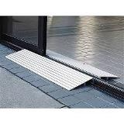  Threshold Ramp
Bath Chair Round  Compact round shower stool for tight spaces. $35 | 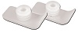  Walker Glide Skis | 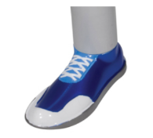  Walker Glides

Shower / Bath
Commode Standard 3 in 1  Gray powder-coated, steel-welded construction. Durable plastic Snap-on seat with lid, removable tool-free back. Plastic arms for comfort, 12-quart bucket with metal handle, cover and splash shield. Width between arms is 18 inches. Weight capacity 350 lbs. $50 | Commode Standard 3 in 1 With Drop Down Arms  Has 12-quart pail, sleeve & lid, adjustable legs, molded plastic arms that drop down for easy transfer. Weight capacity 300 lbs. $74 | Commode Heavy Duty 3 in 1 Folding  Gray powder-coated, steel-welded construction, Durable plastic 16 ½ inches deep. Snap-on seat with lid, removable tool-free back, plastic arms for comfort, 12-quart bucket with metal handle, cover and splash shield. Width between arms is 24 inches. Seat width: 13.5 inches, Seat depth: 16.5 inches. Weight capacity 650 lbs. $98
Rolling Shower Chair / Commode  Lightweight and durable, padded, open front, vinyl toilet seat, 4 non-skid, rust resistant, swivel casters (2 rear locking). 12-quart. bucket and cover. Weight capacity 300 lbs. $120 | Toilet Safety Rails  Make the bathroom safer for individuals needing assistance in raising from a seated position. Adjustable arm width and height 25.5 - 29.5 inches, attaches to standard toilet. Weight capacity 300 lbs. $40 | Raised Toilet Seat  Hinged  Two piece, hinged seat riser. Allows the ring to be lifted for cleaning. Elevates by 3.5 or 4 inches. Hardware kit included.  Standard or Elongated Styles.  3.5-inch rise: $50  4-inch rise: $55
Raised Toilet Seat Locking with removable arms  Round or Elongated style available. Heavy-duty molded plastic construction provides additional strength and durability. Locking device has larger, heavy-duty worm screw and locking plate to ensure a safe, secure fit. Raises toilet seat height 5 inches. $68 | 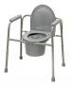  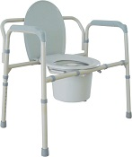  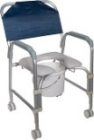  Commodes | 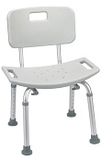  Bath Chair with Back

Walker / Accessories
Cup Holder – Universal  Universal Cup Holder easily attaches to most wheeled walkers, wheelchairs and rollators. $19 (pair) | Glide Caps  Allows walker to slide smoothly over most surfaces. These replace existing rubber tips for smoother and easier gliding, Ideal for indoor use. $9 (pair) | Glide Covers  The glide cover can easily be added to the walker, for use over existing rubber tip. The glide covers increase the life of the walker tips. $9 (pair)
Glide Skis  The glide skis can easily be added to the walker back legs to help “glide” the walker.  $10 (pair) | Glides – Bunny Slippers  Stylish Slippers allow walker to glide easily & smoothly over most surfaces. (Colors: Blue, Pink, or Purple) $10 (pair) | Glides – Sandals  Stylish Sandals allow walker to glide easily & smoothly over most surfaces. (Colors: Blue, Pink, or Purple) $10 (pair)

Walker / Accessories

Glides – Sneakers  Stylish tennis shoes allow walker to glide easily & smoothly over most surfaces. (Blue, Pink, or Purple) $10 (pair) | Glides – Tennis Ball  Provides a quiet, smooth and durable glide when used with walker. $18 (pair) | Walker Basket  Used with most 1 inch folding walkers. Includes plastic insert tray and a cup holder; makes transporting personal items a cinch. $24
Walker Tray Universal  Fits most manufactured walkers. Easy to clean, durable plastic with a cup holder. $35 | Walker Rear Glide Brakes  For use on back of wheeled walkers. Nylon tip glides along surface until weight is applied to hand grip, which activates the rubber tip brakes. Allows for 8 height adjustments. Comes with or without 3inch wheels.  $25 (pair) | Walker Tall Extension Legs  Makes height adjustments from 36 to 43 inches on a standard adult walker. $25 (pair)
Walker Wheels 3-inch Swivel  These heavy duty swivel wheels allow walker to roll easily and smoothly in any direction and over irregular surfaces; includes rear glide caps. 8 height adjustment settings. $19 (pair) | Walker Wheels 5-inch  Non Swivel  These heavy duty non-swivel wheels allow walker to roll easily and smoothly in any direction and over irregular surfaces; includes rear glide caps, 8 height adjustment settings. $18 (pair) | Walker Wheels 5-inch Swivel  Rubber wheels with rear glide caps allow walker to roll easily and smoothly. Converts folding walker into wheeled walker, 8 height adjustments. 2 sided positioning. $25 (pair)
Walker Adult Double Button With or Without Wheels  Deluxe folding walker, double button folding action. Vinyl hand grips.  Walker without wheels: $30  Walker with 5-inch wheels: $50 | Walker Adult Double Trigger With or Without Wheels  Pull up on extended dual palm trigger release levers, ideal for individuals with limited finger dexterity. Vinyl, ribbed contour handle grips, Weight capacity 350 lb.  Walker without wheels: $40  Walker with 5-inch wheels: $50 | Walker Adult Heavy Duty Double Button With or Without Wheels  Folding, double button action. This walker is designed with a wider and deeper frame design for larger individuals up to 500 lbs.  Walker without wheels: $50  Walker with 5-inch wheels: $70
Walker Junior Double Button With or Without Wheels  Deluxe folding walker, double button folding action. Vinyl hand grips. Weight capacity 350 lb.  Walker without wheels: $30  Walker with 5-inch wheels: $40 | Walker Junior Double Trigger With or Without Wheels  Pull up on extended dual palm trigger release levers, ideal for individuals with limited finger dexterity. Vinyl, ribbed contour handle grips, 350 lb. weight. capacity.  Walker without wheels: $40  Walker with 5-inch wheels: $50 | 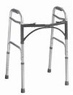  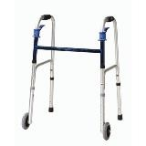  Double Button Walker  Double Trigger Walker

Walker / Accessories
Walker – Hemi  Only 3 inches deep when folded with two-levels. Provides support for standing from a seated position. For one arm use, lightweight side walker combines support and stability. Extra hand grip for ease of folding. $45 | Walker Clever Lite  The Clever-Lite Walker sets itself apart from other wheeled walkers in that it features a seat with a flexible backrest that can flip up or down, so you to rest when needed. Also, this walker has wheels that can be either set to swivel or fixed positions, giving you more control of how you want to roll. $126 | Rollator 2 in 1 – Duet  Combines transport chair & rollator into one. Contoured, two position, padded back rest attaches to front or back, large 8-inch casters. Lock prevents accidental folding. Footrest folds down when being used as a transport chair and folds out of the way as rollator. $170
Rollator 6-inch Casters  Four-wheel walker w/seat, height adjustable arms with locking hand brakes, storage pouch. 250 lb. weight capacity. $130 | Rollator 7-inch Casters  Four-wheel walker w/seat, height adjustable arms with locking hand brakes, storage pouch, Weight capacity 250 lb.  $140 | Rollator 7.5- inch Casters  Four-wheel walker w/seat, height adjustable arms with locking hand brakes, storage pouch. $145
Rollator Oversized Go Lite  Extra wide, padded seat is 18 x 13 inches, wire basket hangs under seat or in front of walker; The handles raise to 39inches, has 8-inch casters, weighs 26 lbs. 400 lb. weight capacity. $160 | 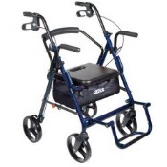  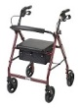  Duet  Rollator | 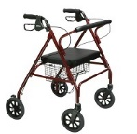  Go Lite Rollator

Wheelchair - Manual
Folding Transport Chair  17-Inch  Weighs only 19 lbs. with 8-inch composite wheels. Back folds down for storage and transport. Standard rear wheel locks.  $115 | Folding Transport Chair  19-Inch  Weighs only 19 lbs. with 8-inch composite wheels. Back folds down for storage and transport. Standard rear wheel locks.  $115 | 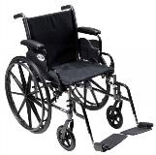  Cruiser III Manual Wheelchair
Wheelchair: Cruiser III  16-Inch  Removable flip back desk arms; carbon steel frame w/silver vein finish. Lightweight Mag-style wheels. Padded nylon seat and back. Your choice of elevating or swingaway legs.  Max weight: 250 pounds. $170 | Wheelchair: Cruiser III  18-Inch  Removable flip back desk arms; carbon steel frame w/silver vein finish. Light weight Mag-style wheels. Padded nylon seat and back. Your choice of elevating or swingaway legs.  Max weight: 300 lbs. $180 | Wheelchair: Cruiser III  20-Inch  Removable flip back desk arms; carbon steel frame w/silver vein finish. Light weight Mag-style wheels. Padded nylon seat and back. Your choice of elevating or swingaway legs.  Max weight: 300 lbs. $185

BARGAIN BASEMENT
Gently used equipment available at ATI in Salem
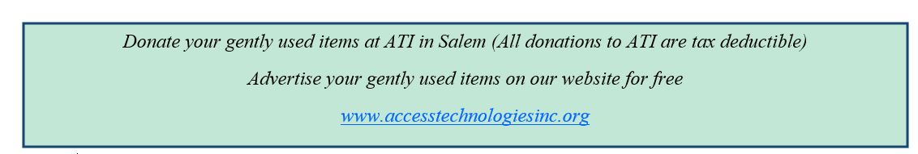
Daily Living  NiftyNabber Pro U6560  Easy to use squeeze handle grabber. Strong enough for heavy-duty work, this reacher is light enough to protect from back and arm strain. $30 | Daily Living  Reclining Bath Chair U6562  Consists of a PVC frame, mesh seat and locking casters. $100 | Hearing  In-Line Phone Amplifier U569LL  Walker W10 is universally compatible and designed to increase incoming signals with up to 26 decibels of gain above the normal level. $5
Hospital Beds  Bed Rail U6561  Invacare Half Length Bed Rail. (Twin). $25 | Medical  Chair Sensor Pad Alarm U6522  Helps to prevent a fall by placing the Chair Sensor Pad on the seat of a wheelchair or in the bed to alert you when your loved one is getting up. $20 | Medical  Pediatric Wheelchair U6551  Pediatric Invacare Orbit Tilt-in-Space with detachable seat frame. 55-degree tilt range, adj. pivot point, telescoping front riggings. Seat grows from 10”x10” to 16”x16”. Weight capacity 150 pounds. $20
Technology Cases FREE  iPod 2Gen Cover U5797  iPad Keyboard/Case U5737  Fits iPad Pro/Air 2 (9.7)  Otterbox iPad Case U6538  Fits iPad Pro/Air 2 (9.7) | Technology FREE  XL-40 Amplified Phone U6419  Extra loud ringer, backlit keypad, hearing aid compatible handset. | Technology FREE  Cordless Phone U6430  RadioShack brand amplified cordless phone. Amplified up to 35 decibels. Large backlit keypad, adjustable tone control.
(Hiring - continued from page 1)

Before the Visit:
Do as much of the pre-service consultation as possible before the service provider arrives.
- Check with your local health department to see if there is a stay-at-home order in your state or local community that restricts non-essential activities or services. If a stay-at-home order is in effect in your community, consider if the service request is essential or if it can be delayed.
- If you or someone in your home has COVID-19, symptoms consistent with COVID-19, or has been in close contact with someone who has COVID-19, wait to schedule non-emergency services that require entry into your home until it is safe to be around others.
- Do as much of the pre-service consultation as possible before the service provider arrives, to reduce the amount of time the service provider spends inside your home. For example, discuss the details of the service request on the phone or by email, and send pictures ahead time.
- Discuss any COVID-19 precautions the service provider is taking, including the use of masks for the duration of the service visit, any pre-screening procedures (such as temperature checks) and using the restroom during the service call.

During the Visit:
- Do not allow service providers to enter your home if they seem sick or are showing symptoms of COVID-19.
- Ask the service provider to wear a mask before entering your home and during the service visit. Also, you and other household members should wear a mask. Consider having clean, spare masks to offer to service providers if their mask becomes wet, contaminated or otherwise soiled during the service call.
Ask the service provider to wear a mask before entering your home
- Avoid physical greetings, for example, handshakes.
- Minimize indoor conversations. All conversations with the service providers should take place outdoors, when possible, and physically distanced indoors, if necessary.
- Maintain a distance of at least 6 feet from the service provider, and limit interactions between the service provider and other household members and pets.
- During indoor services, take steps to maximize ventilation inside the home, such as turning on the air conditioner or opening windows in the area.

After the Visit:
- If possible, use touchless payment options or pay over the phone to avoid touching money, a card, or a keypad. If you must handle money, a card or use a keypad, wash your hands with soap and water for at least 20 seconds or use hand sanitizer with at least 60% alcohol after paying.
- After the service is completed, clean and disinfect any surfaces in your home that may have been touched by the service provider.

(The Unexpected - continued from page 2)
Transport chairs are great on occasions when you experience difficulties walking through the store, into the doctor’s office, or just for a stroll in the neighborhood with a loved one. Look for a lightweight model, that folds easily for stowing in your vehicle.
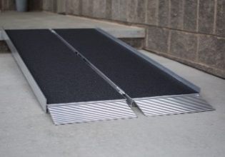
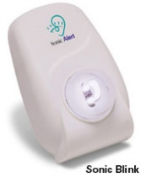
Portable ramps are wonderful accommodations for individuals who use any type of mobility aid such as a walker, wheelchair, knee scooter, or simply find those steps into the home painful to the knees, back or hips.
Alerts and Signalers are great when our ears don’t work so well, and we may not know when the telephone is ringing, or someone is knocking at the door.
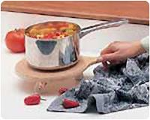
There are a variety of adaptive eating utensils, dinnerware, and meal prep aids designed to assist individuals with tremors, limited grip or range of motion. Examples include utensils with built up handles, rocker knives, weighted utensils, the popular Liftware Steady, partitioned dishes, double spatulas, and the Kitchen Rollabout.
We understand a disability often requires changes in how a person lives, works, travels, or spends their free time. If you are unsure where to start, call Access Technologies, Inc. Our AT Specialists are available to talk with you and demonstrate simple technologies that can make this new part of life a little easier. Did you know ATI has a device lending library where you can try out devices before making a purchase? Give us a call at 503-361-1201.

